Carlo Altomonte,ª Marcella Nicolini,^{b} Dario Pellegrino^{c}

The impact of Chinese imports on Italian firms’ price-cost margins:
An empirical assessment

Abstract
This paper investigates the relationship between price-cost margins of an advanced economy and Chinese imports penetration using a sample of firms from Italy and France. In order to deal with endogeneity concerns, it instruments Chinese imports with its shares in USA, Japan, and South Korea. Additionally, it disentangles short-run from long-run effects: in the short-run there is a remarkable pro-competitive effect of markups squeezing, while in the long-run a mild positive impact signals a process of restructuring towards quality upgrading. Furthermore, there is evidence of heterogeneity of reaction across firms: in particular, the most productive firms display a better positive impact also in the short run.

JEL codes: F12; F14; L11; L60

Keywords: price-cost margin; Chinese imports; firm heterogeneity

_________

ª Bocconi University
^{b} University of Pavia and FEEM
^{c} OECD and Bank of Italy
The authors would like to thank Luigi Benfratello, Anna Bottasso, Giovanni Bruno, Alessia Paccagnini and seminar participants at Centro Studi Luca d’Agliano-University of Milan for providing helpful comments.

1. Introduction
One of the most relevant economic issues in the last two decades is the astonishing growth of China, which has grown in a central player of the global economic system. International trade with China has disruptive effects on advanced economies’ economic environment, on the one side allowing wide access to cheap goods for consumers, on the other side putting several industrial sectors under increasing strain. China is not the first country to implement a successful export-oriented development strategy based on low-wage manufacturing; nevertheless its huge demographic dimension brings about much bigger competitive implications relative to other similar industrialization experiences like the ones of Taiwan or South Korea. “The China price” are the three scariest words for western producers, according to Business Week magazine (Dec 6th, 2004).
The aim of the present paper is to investigate to what extent imports from China affect the competitive pressure faced by European firms. Two sample of firms have been used, one from Italy and another one from France, from 2000 to 2007, a time horizon which covers the years when Chinese export surge has been strongest, particularly following China entrance into the WTO in 2001. As a synthetic measure of firm level-competitive pressure we use price-cost margins, and we assess how this indicator reacts to increased import penetration. In other words this paper tries to assess the causal relationship existing between price-cost margins (PCMs) at firm level and domestic import penetration from China within the same sector. This relationship does not have to be necessarily negative as it might seem: at least in a long-run perspective, a positive relationship might arise because of reorientation towards higher-value added products and self-selection of the most efficient firms. Hereby, the identification choice through a dynamic model allows disentangling the immediate short-run impact from structural long-run one. In order to overcome endogeneity problems stemming from omitted variable bias and reverse causality concerns, we choose to implement an instrumental variables strategy which uses Chinese import shares in U.S.A., Japan and Korea. We choose such countries for the instruments as they are relevant, being large importers of Chinese goods, and exogenous.
Chinese import penetration yields a significant negative impact on PCMs in the short-run, while in the long-run there is a reversal to a positive coefficient, signaling a process of restructuring towards quality upgrading undertaken by firms. Furthermore there is evidence of heterogeneity of reaction among firms: in particular firms showing higher productivity are the ones which are expected to better react in the long run, confirming the hypothesis that international trade triggers a significant selection process among firms.
This paper is structured as follows: Section 2 provides an overview of related theoretical and empirical literature, Section 3 describes the sample and discusses variables’ construction, while Section 4 explains the identification strategy, the choice of instrumental variables and the derivation of the estimated equations. Section 5 discusses the main results and their economic implications, presents some robustness checks and extends the model by relaxing the assumption of homogenous impact in order to grasp further economic insights. Finally, Section 6 concludes.

2. Literature background
A useful theoretical benchmark for the present analysis can be found in Melitz and Ottaviano (2008): its main features, in particular heterogeneity of firms’ productivity and endogenous markups, provide a picture of industrial competitive dynamics which allows to build up a consistent empirical strategy to estimate the implications of increasing trade openness. The heterogeneity of firms has been illustrated in recent empirical studies, which have reported a much wider within-sector heterogeneity of firms’ performance relative to what traditional trade theory would suggest. From a theoretical perspective, such heterogeneity implies that we are shifting the notion of comparative advantage from a sector level (like in a ricardian framework), to a firm level: it follows that gains from trade derive not from a specialization in the relatively more productive sectors, but rather from the opportunity to reallocate in each economy resources from least to most productive firms (or specialization in core products), even within the same economic sector. The key innovation of the Melitz Ottaviano model, which is particularly useful for the sake of this analysis, is the endogeneity of markups, an hypothesis derived by assuming a quasi-linear demand system. This implies that markups are not pre-defined, but each firm chooses its optimal level: this is decreasing with respect to market size, which is a measure of “toughness of competition”. International integration induces more foreign firms to serve the domestic market, thus increasing market size. As a consequence markups are expected to decrease with trade openness.
According to this framework welfare gains from an increase in trade openness stem from three main sources. First, imported goods from foreign firms increase competitive pressure on domestic firms: the straightforward consequence is a reduction of markups. Second, a selection effect on firms, which reallocate resources and production within domestic manufacture towards the most efficient firms, boosting aggregate productivity, i.e. reducing average costs. The third effect consist in an increase in the variety of products deriving from foreign imports. The first two effects result both in a downward pressure on domestic prices. This paper instead would disentangle the “pure” competitive effect, which is related to markups, ruling out the effect of reduction of prices driven by increased efficiency or by a reduction of imported inputs price. We expect such impact on markups to be mainly negative, at least in the short run, i.e. when the number of operating firms and the product mix chosen by each firm are not endogenous but fixed. In the long run, this effect might be reverted, leading to an increase of average markups, basically for two reasons. First, firms could choose to restrict or switch their product mix toward "core" (higher markups) products (Bernard et al., 2006; Eckel and Neary, 2009; Iacovone and Javorcik, 2008; Baldwin and Gu, 2009). Second, since foreign competitive pressure forces less efficient firms to exit the market, firms which are able to stay in the markets are to ones which are able to set relatively higher markups. The former effect is basically related to multiproduct firms, or anyway to firms which are big and/or innovative enough to react switching their productive processes and/or output. It follows that heterogeneity of firms entails heterogeneous reactions to international economic integration processes. The second part of the empirical analysis will be devoted to detect how import penetration may differently impact across firms.
Melitz and Ottaviano measure trade openness as the (inverse of) trade costs, which can consist of juridical or physical barriers which add up to the total cost of exporting firms. The effect of a trade costs decrease is equivalent to an increase in market size, which results in an increase of competitive pressure. In order to empirically test the implications of the model with respect to PCMs it can be useful to derive, starting from trade costs, a better implementable measure of trade openness, in terms of trade exposure. Chen et al. (2009) consider import penetration, defined as the ratio of imports from a foreign country on apparent consumption, and derive it theoretically as a function of trade costs, which results, as expected, in a monotonous negative relationship.
There is a wide empirical literature which has investigated industrial implications within advanced countries of trade with low-wage countries (and in particular China) by taking into account a broad spectrum of features, like prices, productivity, employment. The rationale to focus on low-wage countries relies on the possibility to disentangle more clearly the influence of comparative advantages with respect to a framework which, by taking into account aggregate trade exposure, would consider symmetrically imports from developed countries and low-wage countries. Among others, Bernard et al. (2006) analyze the impact of low-wage import penetration on U.S. plant manufacturing, finding a negative relationship of imports from low-wage countries with the probability of plant survival and employment growth, these effects being milder for capital and skill intensive firms. At the same time, trade exposure is supposed to positively affect probability of industry switching, suggesting the existence of industrial restructuring dynamics triggered by foreign competitive pressure.
We might identify two main strands of empirical research which are intertwined with the present analysis. The first concerns the impact of trade on prices, therefore encompassing aggregate effect on costs and markups. In particular, Bugamelli et al. (2010) investigate the relationship between Chinese imports and firm-level prices of Italian firms. They find a robust negative relationship among them, which displays a remarkable heterogeneity of reaction, being the effect stronger for smaller firms and low-technological sectors. Auer and Fischer (2010) and Auer et al. (2010) find a negative impact of low-wage countries imports on sector-level prices within European countries, adopting a methodology which has been undertaken also in Auer et al. (2010): they develop a sophisticated instrumental variables strategy which essentially relies on the notion of comparative advantage: as Chinese manufacturing sector growth has a greater impact on imports from labor-intensive sectors, they instrument import penetration with the interaction between Chinese manufacturing growth and labor-intensity. Indeed, spurious correlation between imports and prices is a rather critical issue: the nature of this risk, and the methodology used to cope with it will be explained in the following section.
A second strand of literature deals with the relationship between trade competition and “quality upgrading”. While opening up to international competition is commonly believed to trigger a downwards pressure on prices and markups, it might also stimulate effects of the opposite sign, in terms of “escape competition”: firms, in order to avoid a more and more profound profit squeezing, may restructure their product mix towards higher value added products which are characterized by lower product elasticity. This point is particularly relevant for developed countries: in order to cope with cheap imports deriving from low-wage developing economies, the optimal strategy would be to focus towards products which are abundant of physical and human capital as well as technological content. There is evidence over the last decade that Italian manufacture has undergone a relevant process of upgrading (di Giacinto and Micucci, 2009). A compelling question is whether a causal link can be found between foreign competition and industrial restructuring directed towards quality upgrading. Focusing on Chinese competition, Monfort et al. (2008) find that Belgian textile sector reacted to two shocks, the entrance of China into the WTO (2001) and the end of Multifibre Agreement (2005), by significantly increasing the value per unit and the skilled/unskilled labour ratio. Fernandez and Paunov (2009) provided similar evidence on a sample of manufacturing plants, finding that lower transport costs foster product quality. Martin and Méjean (2011), analize the evolution of French exports in the period 1995-2005 and observe an overall increase in unit per value, arguing that around one fifth of this quality increase is due to low-wage import competition. However, industrial restructuring brought about by foreign competitive pressure does not mean for developed countries to simply abandon sectors which are traditionally considered as “labour intensive” : Brenton et al. (2000) find that within countries like Italy, a sector like footwear, which is traditionally considered as “low-skill intensive”, managed to keep its output and employment level and to increase his export/output ratio in a context of increasing competitive pressure from emerging countries. This finding suggests that even within a fine level of sector-disaggregation, intra-sector heterogeneity is relevant and, in line with the new strand of trade theories, consequences of trade penetration consists not only in inter-sector but also in intra-sector resources reallocation.
Summing up, the first empirical strand of literature shows pro-competitive evidence for import penetration in terms of price (and presumably markups) compression, drawing a relationship which is basically short-run, since domestic firms reaction is contemporeanous or at most lagged of one year relative to the change in import penetration. The second strand shows a restructuring process which is triggered by foreign competition and which could bring, on a longer time span, a counteracting effect on markups, i.e. leading firms in advanced countries to concentrate in niche markets characterized by lower demand elasticity. This analysis integrates the two kinds of impacts within the same specification in order to capture a comprehensive picture encompassing immediate and structural markups reaction to Chinese competitive pressure. In doing it, we basically follow Chen et al. (2009) strategy, which presents evidence on the impact of aggregate import penetration on prices and markups A second innovative contribution of this paper lies in the development of a set of instrumental variables to cope with endogeneity problems related to the markups-import relationship.
3 Data description
3.1 Data sources and descriptive statistics
Data on international trade flows have been retrieved by BACI dataset, provided by CEPII, which contains comprehensive data about bilateral trade in 6-digits Harmonized Commodity Description and Coding System classification; these data have been converted into 4-digit NACE rev. 1.1 classification in order to compare them with firm level observations, as we have information on the primary activity of firms at this level of disaggregation. Figure 1 reports some descriptive statistics of the share of imports from China. It is evident that this figure has remarkably accelerated after Chinese entrance in the WTO in 2002. Through eight years, the share of Chinese imports has roughly doubled in both countries. Nevertheless this growth is not uniform across sectors: the standard deviation for the increase of share of imports by 4-digit NACE is respectively 6.52% and 7.63% for Italy and France, respectively. That implies a relevant heterogeneity of increase of Chinese competitive pressure which can be exploited for the sake of the present analysis.
Figure 1: Chinese import shares
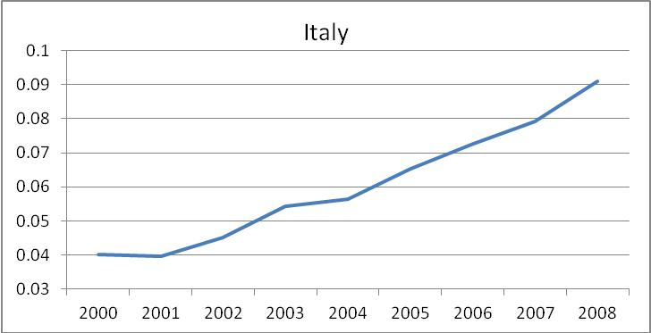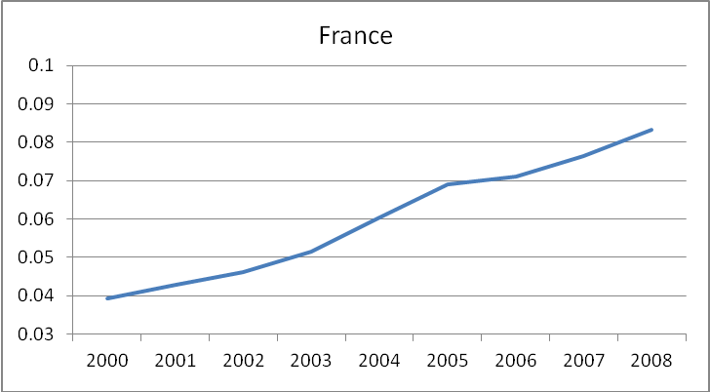

Firm-level data come from AMADEUS, an European-wide dataset provided by Bureau van Dijk, containing disaggregated firm data retrieved from balance sheets. We consider manufacturing firms data in Italy and France from 2000 to 2007. The two samples have been cleaned of the few observations containing negative or missing observations of the variables of interest. The results are two firms unbalanced panels, each one containing an average of around 30.000 yearly observations. We consider NACE rev 1.1 codes from 15 to 36.
Table 1 describes the firm size distribution of the samples, in terms of employees. As it can be seen, the largest share of observations is given by small-medium size firms.
Table 1: Firm size distribution
number of employees | Italy (%) | France (%)
n<10 | 37.12 | 54
10<n<30 | 33.16 | 22
30<n<50 | 12.1 | 9.51
50<n<100 | 9.44 | 5.97
100<n<200 | 4.51 | 4.05
n>200 | 3.67 | 4.5

Table 2 presents the mean values for some key firm indicators. The Italian sample seems to be somehow of higher quality in terms of labor productivity and capital intensity. Concerning the level of sales and employees, even though the two sample have the same mean, the French sample is more skewed, as signaled by the lower median.

Table 2: Firms characteristics
Italy
Variable (1000s of €) | Mean | SD | Percentiles
Variable (1000s of €) | Mean | SD | 1% | 10% | 25% | 50% | 75% | 90% | 99%
Sales | 10132 | 203206 | 76 | 304 | 708 | 1712 | 4498 | 11970 | 108430
Employees | 57.7 | 886 | 1.0 | 3.0 | 7.0 | 15.0 | 36.0 | 85.0 | 540.0
Labor Productivity | 132.5 | 2501 | 7.1 | 39.9 | 57.2 | 83.3 | 127.3 | 207.4 | 654.3
K/L ratio | 75.9 | 1075 | 0.6 | 5.1 | 12.0 | 28.8 | 64.1 | 131.5 | 589.8
Wages | 36.3 | 934 | 6.1 | 21.6 | 25.1 | 27.1 | 34.0 | 43.5 | 82.7
France
Variable (1000s of €) | Mean | SD | Percentiles
Variable (1000s of €) | Mean | SD | 1% | 10% | 25% | 50% | 75% | 90% | 99%
Sales | 10974 | 319361 | 31 | 120 | 272 | 750 | 2421 | 8522 | 142122
Employees | 58.0 | 611 | 1.0 | 2.0 | 4.0 | 9.0 | 29.0 | 84.0 | 777.0
Labor Productivity | 106.9 | 127 | 19.0 | 39.8 | 53.8 | 73.6 | 105.3 | 157.5 | 454.0
K/L ratio | 43.2 | 1654 | 0.0 | 2.1 | 5.0 | 11.6 | 25.6 | 53.4 | 258.4
Wages | 39.0 | 171 | 8.5 | 21.5 | 27.6 | 34.8 | 44.1 | 56.9 | 105.7

Table 3 describes the sector distribution for each sample.

Table3: Sector firms distribution (%)
NACE | Description | Italy (%) | France (%)
15 | food products and beverages | 3.75 | 4.46
16 | tobacco products | 0.01 | 0
17 | Textiles | 5.2 | 2.42
18 | wearing apparel; dressing and dyeing of fur | 3.68 | 3.19
19 | Tanning and dressing of leather; luggage, handbags | 5.46 | 1.19
20 | wood and wood products | 4.1 | 6
21 | pulp, paper and paper products | 2.47 | 1.76
22 | Publishing, printing and reproduction of recorded media | 5.18 | 12.94
23 | coke, refined petroleum products and nuclear fuel | 0.09 | 0.02
24 | chemicals and chemical products | 4.29 | 3.39
25 | rubber and plastic products | 3.5 | 5.37
26 | non-metallic mineral products | 6.56 | 5.15
27 | basic metals and fabricated metal products | 1.2 | 0.43
28 | fabricated metal products, except machinery and equipment | 12.63 | 8.8
29 | machinery and equipment | 17.66 | 20.49
30 | office machinery and computers | 1.15 | 0.32
31 | electrical machinery and apparatus | 6.28 | 3.56
32 | radio, television and communication equipment and apparatus | 2.04 | 1.93
33 | medical, precision and optical instruments, watches and clocks | 3.29 | 6.31
34 | motor vehicles, trailers and semi-trailers | 1.8 | 2.08
35 | other transport equipment | 1.6 | 1.8
36 | Furniture | 8.05 | 8.37

3.2 Variables’ definition
We define price-cost margins (henceforth PCM) through the Lerner index, i.e. as the percentage distance of prices from marginal costs: by definition this measure is gross of investments in fixed costs. It can be considered as a rivalry indicator, being inversely related to the intensity of competition in the sector. Furthermore, from a firm-level perspective, it is a firm strategic choice which is a function of residual demand, resulting as an indicator of market structure. It should be noticed that dynamics of this indicator encompass a wide spectrum of changes in competitive behavior of firms, like pricing strategies, quality upgrading, product mix changes and the evolution of market shares. In order to construct an empirical measure of PCM we follow Tybout (2003) and use average variable costs (cost for materials and employees) in order to proxy for marginal costs, since they cannot be directly retrieved through balance sheet data. It follows that the resulting measure of PCM calculated for firm i at time t is:
${\text{PCM}}_{\text{it}}=\frac{{\text{sales}}_{\text{it}}−{\text{variable costs}}_{\text{it}}}{{\text{sales}}_{\text{it}}}=\frac{(p⋅q)_{\text{it}}−(c⋅q)_{\text{it}}}{(p⋅q)_{\text{it}}}=\frac{p_{\text{it}}−c_{\text{it}}}{p_{\text{it}}}$ (1)
Where cost represents average cost and is price. Figure 2 provides a picture of evolution of the sample means of PCM for the two countries (weighted for turnover), clearly showing a downward pattern for the markups dynamics, in particular within the French sample.
Figure 2: Aggregate PCM evolution
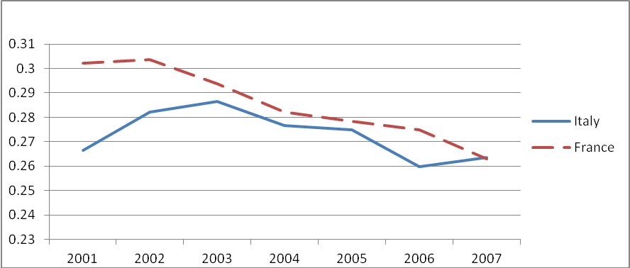
The next step is be to choose a measure of industry domestic market exposure towards Chinese imports, which could properly work as explanatory variable for PCMs. The most widely used measure to grasp foreign competitive pressure is the ratio between imports and apparent domestic consumption, where the latter is defined as the domestic production minus trade balance. In particular, Chen et al. (2009) draw a positive monotonus relationship between trade barriers and that indicator, generally called as “import penetration”. Following this approach, Chinese import penetration would be defined for country i, sector s, time t, and N countries i trades with:
(2)
The economic interpretation for this indicator is rather straightforward: as a share of domestic demand satisfied by foreign (in this case Chinese) products, and from a theoretical point of view, it would be a good instrument to use in order to answer the research question of this paper. However some issues concerning data reliability prevent us from adopting such a measure. We could not find production data and bilateral trade flows at NACE-4-digits level of disaggregation within the same data-source, in order to build this measure we need to merge EUROSTAT production data with BACI trade flows data, but the two sources result being rather inconsistent between each other: in particular, the level of correlation between aggregate imports (NACE 4-digit) showed by BACI and EUROSTAT for Italy and France is respectively 88.9% and 95.5%, while the mean-level from EUROSTAT is respectively 13.35% and 18.73% higher rather than BACI. These figures cast serious doubts on the homogeneity of the methods of calculations followed by the two institutions, and therefore about the opportunity to merge these two data sources into a single index. We therefore adopt an alternative indicator entirely calculated from BACI data, a “relative” measure of Chinese import penetration, which considers the share of Chinese imports on total imports:
(3)
This measure has been already used as a proxy of competitive pressure from imports (Bugamelli et al., 2010). In terms of economic interpretation it is relatively weaker than the former index, measuring the relevance of Chinese products relatively to other imported products and not to the whole domestic market. For instance, at least as a theoretical possibility, it might remain constant while Chinese imports are growing remarkably, if imports from other foreign countries are growing at the same pace. As a matter of fact, it is anyway expected to capture rather well dynamics Chinese products penetration, especially in period like 2000-2007, which has been characterized by a boom of Chinese imports as shown in Figure 1. A further reason to prefer relative import penetration to the absolute measure is related to potential mitigation of endogeneity as will be explained in the next section.

4. The empirical strategy

4.1 The endogeneity problem
A simple correlation analysis between competitive pressure from Chinese imports and European firms’ price-cost margins provided by an OLS model would suffer of endogeneity in explaining the causality pattern. Firstly, one can expect omitted variables which affect demand and supply conditions, in particular local demand conditions: for instance, a positive shock of demand would boost both imports and level of prices set by firms. Concerning supply conditions, an additional troublesome source of bias derives from reverse causality: the least competitive sectors within an economy are the ones which allow firms to extract higher extra profits, but right for the same reason they could result more attractive for foreign firms as export markets. Omitted demand conditions and reverse causality are expected to bias the estimated coefficients upwards, while omitted supply conditions (such as productivity shocks) are expected to bias it downwards. Hereby we present a strategy to clean out any spurious correlation and to target as much as possible the goal of our analysis.
Firstly we use a fixed effects, which enables to rule-out the impact of time-constant firm-level omitted variables. Secondly, we add time dummies for each year: it means that any time-variant omitted variable which affects firms performance homogeneously across sectors yields no estimation bias. This is particularly useful to get rid of most of the interference given by macroeconomic fluctuations. At NACE 4-digit level it is crucial to structure a set of controls in order to provide a comprehensive picture of competitive pressure faced by firms: we control for trade exposure to foreign products by building a measure of total import penetration, that is called , in order to account for foreign competition stemming from countries others than China:
(4)
Concerning domestic competition, a concentration index has been drawn within the sample firms for each sector, which has been measured summing up market shares of the top four firms for each sector in terms of turnover:
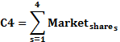
We prefer this measure to control domestic competition relative to the Herfindahl-Hirschman Index, as this tends to be less sensitive to sample characteristics. Additionally, there might be concerns related to attrition bias, as the dataset is not balanced, and the entry-exit from the dataset is not completely random, but may be (even though not necessarily) related to the entry-exit from the market. Therefore, we include a measure of entry-exit at NACE 4-digit level (percentage of firms entering-exiting from the market on total number of operating firm) as additional control.
Finally, we use the following time-varying controls in their natural logarithmic transformation which account for firms’ individual features: size (expressed in terms of employees), capital intensity, i.e. the fixed assets per employee ratio (K_intensity), labor productivity (LP), total factor productivity (TFP), average cost of input (unit_input) and average cost of labor (unit_wage). In a perfect competition scenario, the last two regressors would control for quality of production by measuring quality of intermediate inputs and quality of human capital. In a realistic scenario, those variables would also be negatively affected by competitive pressure, in the sense that extra-profits in protected sectors might be partially distributed to employees and supplies. For the sake of our analysis it means that, while not perfectly measuring quality, these regressors may be nevertheless useful to partially control for sector competitive pressure, to the extent that the latter has not been perfectly captured by the concentration index, whose main shortcomings are basically two: firstly to be essentially sample-drawn, and thus to be potentially affected by sample biases; secondly to consider a level of disaggregation, NACE 4-digit, which often happens to be above the definition of “relevant market”.
Nevertheless, controlling for sector-homogenous shocks and competition and firm level controls might not completely rule out every kind of endogenous correlation which affects the relationship between imports and markups: precisely we cannot get rid of time-varying, sector specific factors which are not captured by measures of competition or firms level controls. Therefore, we implement an instrumental variable strategy. The ideal instrument should be relevant, in the sense of being highly connected to drivers of Chinese import penetration, and exogenous, meaning that it should not be related to factors which might impact European firms markups through other channels rather than Chinese imports. An example of an instrument fully satisfying such conditions would be Chinese manufacturing growth for each sector. Unfortunately that kind of data is unavailable, at least at the needed level of disaggregation, so the research of instruments should be addressed to the closest available proxy.
An available solution is to measure Chinese import penetration from countries different from the ones being object of analysis. Within this range of choice we try to structure the most appropriate set of instrumental variables. For the sake of relevance, one would prefer countries which show similar economic features to the Italian (and French) ones, because the reaction is likely to be similar: therefore we restrict the choice among OECD countries which have a similar level of industrialization. Among them, European countries might be optimal in terms of relevance, because of their similarity to Italy; nevertheless they raise serious concerns in terms of exogeneity: indeed they belong to the same “Single Market”, an entity where physical and juridical barriers to trade result to be rather low, thus they are deeply interconnected to our target of analysis. As a consequence they might not rule out, or might not rule out enough, the local sources of endogeneity. Among the remaining countries we have selected the ones which are supposed to show the stronger connection with Chinese industrial development: it might be sound to select the top importers from China, which, according to a simple gravity model, should be the ones showing the highest ratio in terms of size of economy divided by distance. Indeed, data confirm this theoretical prediction, being U.S.A., Japan and South Korea the countries which outnumber level of Chinese import with respect to any other developed country. These countries show a very low level of interconnection with Italy and France (particularly comparing it to the European partners): concerning import penetration from the instrument countries towards Italy and France, the highest values come from U.S.A., whose share of imports is around 2.4% and 1.6% in Italy and France respectively. Therefore, we can exclude that (at least direct) remarkable influences from instrument to instrumented countries are yielding any spurious correlation in the instrumental variables estimation process. Generally speaking U.S.A., Japan and South Korea are not supposed to perform better in terms of exogeneity with respect to countries like Australia, Chile or Canada, which are smaller or further from China. Nevertheless they should be much more accurate in terms of relevance, since their distance and/or size (and therefore their diversified economy) allows to have a higher sensitivity relative to exogenous Chinese shocks and therefore a more complete and reliable picture of Chinese impact in the world economy through their sector import penetration level.
As mentioned before, the choice of normalizing imports on total imports rather than on domestic demand may mitigate endogeneity problems: indeed the factors of endogeneity which create correlation between Chinese imports and PCMs are supposed to impact, if not with the same magnitude, at least with the same sign on other foreign imports. Therefore, the impact of spurious correlation on the numerator will also impact at the denominator, thus reducing the sensitiveness of relative import penetration measure respect to spurious correlation elements. The extent to which this mitigation will act depends on how the magnitude of which factors of endogeneity impacting on Chinese and aggregate imports are comparable, which is not explicitly measurable.
In conclusion, the assumption that we need to make in order to assess the correctness of our estimation strategy is the following one: the drivers of the share of sector Chinese import in the U.S.A., Japan and Korea with respect to total imports in the same counties, which are sector-specific, time variant and whose time-variation is not regular throughout the years taken into account, do not affect Italian/French price cost margin in other ways rather than through Chinese share of imports in Italy/France.

4.2 The econometric model
We formalize the previous arguments into an equation structured with an autoregressive distributed lag model. Price-cost margins of firm i, belonging to NACE sector s, in year t are regressed on the logarithms of Chinese Import penetration (that we call CH_IP) as follows:
(5)
Where is the set of firm and sector level controls, y_{t} are year dummies, α_{i} are firm level fixed effects and ε_{ist} is the idiosyncratic error term. Since both PCM and CH_IP have been expressed in natural logarithmic transformation, regression coefficients can be interpreted as elasticities.
This dynamic specification, while being rather parsimonious, is able to take into account the persistence of PCM. Additionally, by considering both current and lagged level of CH_IP, it allows to disentangle short-run from long-run dynamics, enriching the scope for fruitful economic interpretation: indeed, while the coefficient for the present CH_IP, β_{0,} captures the immediate impact of an increase of this variable, a structural long-run coefficient can be easily derived by equalizing the current value of PCM with its lagged value:
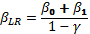 (6)
Nevertheless, this dynamic structure might bring about new endogeneity problem: fixed effects estimation is expected to be biased when the lagged value of the independent variable is included among the regressors (Cameron and Trivedi, 2005). This bias is particularly relevant when the temporal dimension of the panel is particularly short, as it happens in the present analysis. In order to overcome this problem, several estimation methodologies have been developed, relying on estimating the lagged value of the depended variable with appropriated instruments. In this paper, we use the Blundell-Bond technique, which instruments lagged levels of the dependent variable with the first differences of the previous years.
Summing up, our benchmark estimation consists in estimating equation (5) by using two sets of instruments which tackle two different endogeneity problems: a first traditional set of instruments tackles economic sources of endogeneity related to the main regressor we are interested in, CH_IP. A second set of instruments corrects the bias induced by the lagged dependent variable, adopting a dynamic panel specification.
Finally, in order to avoid downward bias of the estimated coefficient variance, standard errors for all the aforementioned specifications have been corrected in order to be robust to both individual arbitrary heteroskedasticity and clustered in order to account for intra-group correlation among observations belonging to the same firm. The latter choice allows to consistently estimate standard errors even in presence of autocorrelation among observations belonging to the same firm.

5. Results

5.1 OLS and baseline IV specifications
In Table 5, we present some estimations obtained through OLS first and by IV, using as instruments the set of U.S.A., Korea and Japan import shares (thus not instrumenting the lagged value of PCM with Blundell-Blond technique). Looking at the baseline OLS model in equation (1), we find that overall correlation of current level CH_IP with PCM is basically null. But, as we know from theory and related empirics, in this kind of situation the estimate of the causal relationship is expected to be strongly upward biased. Controlling for fixed effects (col. (2)), year dummies (col. (3)) and time varying sector and firm level controls (col. (4)) this positive spurious correlation disappears. In col. (5) we introduce country instrumental variables for CH_IP, we find for the first time a interesting short-run coefficient -0.025. If we use simultaneously controls and instrumental variables, as we do in col. (6) the coefficient jumps to –0.041. On the other side, the lagged value coefficient of CH_IP is positive, thus partially reversing in the long-run the instantaneous impact of CH_IP. Notice however that, as the lagged PCM is endogenous its estimate is not reliable and thus the long run coefficient is to be interpreted with caution.

Table 4: OLS and IV specifications
 | OLS |  |  |  | IV
 | (1) | (2) | (3) | (4) | (5) | (6)
VARIABLES | PCM | PCM | PCM | PCM | PCM | PCM
L.PCM | 0.621*** | -0.063*** | -0.063*** | -0.138*** | -0.064*** | -0.139***
 | (0.003) | (0.004) | (0.004) | (0.010) | (0.004) | (0.011)
CH_IP | 0.006** | -0.013*** | -0.001 | -0.006** | -0.025*** | -0.041***
 | (0.002) | (0.002) | (0.002) | (0.003) | (0.008) | (0.010)
L.CH_IP | 0.009*** | -0.015*** | -0.008*** | -0.006** | 0.011 | 0.024**
 | (0.002) | (0.002) | (0.002) | (0.003) | (0.008) | (0.011)
CH_IP - LONG RUN | .0394*** | -.0263*** | -.008*** | -.0105*** | -.0139*** | -.0151***
 | (.0016) | (.0017) | (.0025) | (.0027) | (.0055) | (.0052)
L.lTOT_IP |  |  |  | -0.000 |  | 0.001
 |  |  |  | (0.002) |  | (0.002)
L.C4 |  |  |  | -0.027* |  | -0.044***
 |  |  |  | (0.015) |  | (0.015)
L.K_intensity |  |  |  | 0.007*** |  | 0.007***
 |  |  |  | (0.003) |  | (0.002)
L.size |  |  |  | 0.019*** |  | 0.019***
 |  |  |  | (0.005) |  | (0.004)
L.unit_wage |  |  |  | -0.068*** |  | -0.069***
 |  |  |  | (0.008) |  | (0.007)
L.unit_input |  |  |  | -0.041*** |  | -0.041***
 |  |  |  | (0.005) |  | (0.005)
L.lp |  |  |  | 0.133*** |  | 0.134***
 |  |  |  | (0.011) |  | (0.012)
L.entry |  |  |  | -0.025*** |  | -0.025***
 |  |  |  | (0.004) |  | (0.004)
Year dummies | No | No | Yes | Yes | Yes | Yes
Observations | 320,787 | 320,787 | 320,787 | 211,736 | 308,160 | 197,741
R-squared | 0.404 | 0.005 | 0.007 | 0.013 | 0.006 | 0.011
Number of firm | 79,895 | 79,895 | 79,895 | 61,665 | 67,590 | 47,966
Robust standard errors in parentheses
*** p<0.01, ** p<0.05, * p<0.1

Concerning the simultaneous use of both current and lagged level of CH_IP, it is worthy to point out that such a dynamic specification might be helpful to identify firms reaction towards imports competitive pressure not only from a quantitative perspective, but also from a qualitative one. Indeed short-run reaction is essentially a pure-price reaction, as productive processes and output quality are given, thus prices are very likely to result the only competitive tools they can handle in order to optimize their profits. In the long run firms can choose to change much more aspects of their activities, for instance focusing their product mix towards their core competences or towards higher profitability products, choosing a process of “quality upgrading”: in order to keep up with cheap imports from newly industrializing countries, firms within developed countries have been reacting by shifting their product mix towards market niches which are less sensitive to low-wage countries imports. This is exactly what happens in the benchmark specification of Table 4, i.e. col. (6). From an econometric point of view, it is rather straightforward to notice how the chosen set of instrumental variable is useful to correct the upward bias in the short-run impact of CH_IP.

5.2 The System GMM specification
In Table 5 we correct the endogeneity of the lagged dependent variable. We use both CH_IP instruments and the GMM Blundell Bond instruments. Furthermore, relative to the previous table, two additional elements have been introduced: firstly we add two lags of PCM (L2.PCM), in order to fulfill the Arellano Bond test for serial correlation in the first-differenced errors. Secondly, we add 2 digit-NACE sector dummies to the difference specification, thus accounting also for sector trends.

Table 5: System GMM Specifications
 | (1) | (2) | (3) | (4) | (5) | (6) | (7) | (8) | (9)
VARIABLES | PCM | PCM | PCM | PCM | PCM | PCM | PCM | PCM | PCM
PCM | 0.257*** | 0.215*** | 0.214*** | 0.213*** | 0.216*** | 0.225*** | 0.202*** | 0.080*** | 0.215***
 | (0.010) | (0.011) | (0.011) | (0.011) | (0.011) | (0.016) | (0.016) | (0.029) | (0.020)
L2.lPCM | 0.121*** | 0.084*** | 0.084*** | 0.083*** | 0.086*** | 0.100*** | 0.088*** | 0.101*** | 0.118***
 | (0.007) | (0.008) | (0.008) | (0.008) | (0.008) | (0.011) | (0.011) | (0.011) | (0.011)
CH_IP | -0.155*** | -0.158*** | -0.155*** | -0.158*** | -0.146*** | -0.137*** | -0.113*** | -0.099*** | -0.134***
 | (0.014) | (0.014) | (0.014) | (0.014) | (0.013) | (0.017) | (0.016) | (0.015) | (0.016)
L.CH_IP | 0.184*** | 0.162*** | 0.159*** | 0.162*** | 0.150*** | 0.145*** | 0.121*** | 0.112*** | 0.143***
 | (0.003) | (0.003) | (0.003) | (0.003) | (0.003) | (0.004) | (0.004) | (0.004) | (0.004)
CH_IP–LONG RUN | .0456*** | .0057** | .0057** | .0055** | .0059** | .0130*** | .0111*** | .0156*** | .0147***
CH_IP–LONG RUN | (.0022) | (.0024) | (.0025) | (.0025) | (.0025) | (.0029) | (.0027) | (.0021) | (.0029=
L.C4 |  |  | -0.025*** | -0.023** | -0.023** | -0.024** | -0.017 | -0.012 | -0.023**
 |  |  | (0.010) | (0.010) | (0.010) | (0.011) | (0.011) | (0.010) | (0.011)
L.lTOT_IP |  |  | 0.005*** | 0.005*** | 0.005*** | 0.004*** | 0.003* | 0.001 | 0.004***
 |  |  | (0.001) | (0.001) | (0.001) | (0.002) | (0.001) | (0.001) | (0.001)
L.exit |  |  |  | 0.104*** | 0.087*** | 0.054 | 0.049 | 0.047 | 0.053
 |  |  |  | (0.029) | (0.029) | (0.041) | (0.041) | (0.041) | (0.041)
L.entry |  |  |  | -0.071*** | -0.074*** | -0.109*** | -0.095*** | -0.092*** | -0.108***
 |  |  |  | (0.019) | (0.019) | (0.027) | (0.027) | (0.027) | (0.027)
L.V_IP |  |  |  |  | -0.092
 |  |  |  |  | (0.168)
L.K_intensity |  |  |  |  |  | 0.010*** | 0.032*** | 0.009*** | -0.001
 |  |  |  |  |  | (0.002) | (0.002) | (0.002) | (0.002)
L.size |  |  |  |  |  | -0.016*** | -0.027*** | -0.008*** | -0.008***
 |  |  |  |  |  | (0.001) | (0.002) | (0.001) | (0.002)
L.unit_input |  |  |  |  |  |  | -0.076*** | -0.153***
 |  |  |  |  |  |  | (0.004) | (0.012)
L.lp |  |  |  |  |  |  |  | 0.258*** | 0.063***
 |  |  |  |  |  |  |  | (0.026) | (0.011)
Year dummies | Yes | Yes | Yes | Yes | Yes | Yes | Yes | Yes | Yes
Sector dummies | No | Yes | Yes | Yes | Yes | Yes | Yes | Yes | Yes
Observations | 236,152 | 236,152 | 235,798 | 235,660 | 235,660 | 154,424 | 154,424 | 154,424 | 154,424
Number of firm | 67,200 | 67,200 | 67,100 | 66,962 | 66,962 | 53,647 | 53,647 | 53,647 | 53,647
ar2 | -2.874 | -0.0816 | -0.0662 | -0.0570 | -0.321 | 0.152 | 0.383 | 0.246 | -0.526
ar2p | 0.00405 | 0.935 | 0.947 | 0.955 | 0.748 | 0.879 | 0.702 | 0.806 | 0.599
j | 19 | 40 | 42 | 42 | 45 | 44 | 45 | 46 | 45
Robust standard errors in parentheses
*** p<0.01, ** p<0.05, * p<0.1

Looking at these results, a pattern emerges which is somehow comparable with respect to the non-GMM specification: in the short-run we find a negative impact of Chinese imports, as signaled by the coefficient of the current level of CH_IP. In the long-run this effect reverses, as we find a positive lagged level coefficient. Nevertheless two main differences emerges: firstly the absolute value short-run coefficient is much higher, jumping up from 0.04 to a range comprised between 0.15 and 0.1. This is more realistic from an economic point of view: it means that a 10% increase in import penetration from China is now expected to yield a negative impact on PCM between 1% and 1.5%. Secondly the overall long-run impact become slightly positive, suggesting that the “quality upgrading” process seems now to completely offset the “intensity of competition” impact. Except for col. 1, the Arellano Bond test does not reject the hypothesis of no serial correlation at order two in the first differenced errors, which is a necessary hypothesis for the consistency of the Blundell-Bond System GMM estimation. Additionally, in col. 5 we try to control for the potential impact of cheaper imported inputs through a measure of Vertical Import Penetration (V_IP), i.e. a measure of the sum of sector import penetrations weighted for the input intensity in those sector. However, this measure does not yield significant results.
The IV strategy corrects the estimated coefficients of Chinese import penetrations downwards relative to the OLS model (a result confirmed also in the French sample). This is in line with previous research (Auer and Fischer 2010; Auer et al. 2010; Bugamelli et al. 2010), which shows that by instrumenting import penetration and its impact on prices, regressor coefficients tend to move downwards. This finding leads us to suppose that the elements of endogeneity that we are not able to directly measure act by generating a positive correlation between imports and markups, or at least that positive-correlation yielding factors are dominating. In particular, one can think about demand shocks and the attractiveness of least competitive sectors.
The second striking outcome of this specification is a long-run inversion of the short-run results, being the impact of the lagged level of Chinese import share significantly positive. Accordingly, it seems to emerge that within observed firms there is a remarkable adjustment process, which would have brought them to focus on higher-quality products. Concerning this issue, Pietrobelli and Rabellotti (2006) argue about upgrading as the “high road” to competitiveness, offering higher revenues and wages, as an alternative to the “low road”, which would require price and revenues squeezing. Nevertheless it is noteworthy to remind that the positive dynamic of markups, i.e. unitary profits, does not imply that firms do not loose even in the long-run in terms of overall profits or turnover because of Chinese imports. Furthermore, the positive coefficient does not mean that there is no downward competitive pressure on prices/profit-margins in the long run, but only that structural reaction processes like resource reallocation and product mix repositioning are large enough to offset it and to yield an overall positive results.
Regarding the controls, as they are affected by several channels of correlation, a rule of prudency would suggest that no rigorous inference should be drawn beyond few heuristic considerations. However, their interest for current analysis is at most due to the indirect role they play to help to correctly assess the main causation channel we are interested in.
Summing up, the chosen model has provided us two channels of causation between Chinese imports and PCM. The first one is a short-run deviation from equilibrium, and it is intrinsically negative, the second is a long-term equilibrium relationship which reverses the previous one. In order to clarify how the two different impact could interact over the years, which means particularly to gather insights about the speed of long-term correction, we run a theoretical exercise, which consists in detecting, other things equal, the dynamic impact of a one-shot variation of import penetration throughout the years. At the beginning of the simulation, i.e. year=0, we imagine to be in an equilibrium characterized by a constant level of PCM over time. For the sake of simplicity, the logarithm of PCM is set to zero. We impose that during year one Chinese import penetration doubles, i.e. we have a unitary increase of its logarithm, and that afterwards it keeps on being at the same level. Keeping all other variables constant, we can observe how PCM evolves in a model characterized by Italian estimated regressors. Resulting PCMs are shown in Figure 3, which appears rather self-explanatory. Even though the long-run equilibrium level of convergence could appear, from an economic point of view, not dramatically different from the starting point level, the case to argue for a reversal of short-run effect is much stronger. Regarding this issue, Chen et al. (2009) find a quite comparable markups reaction towards an increase of aggregate import penetration: a remarkable instantaneous contraction followed by a weak evidence of reversal in the long-run.
Figure 3: PCM evolution following one-shot permanent increase of Chinese Import penetration
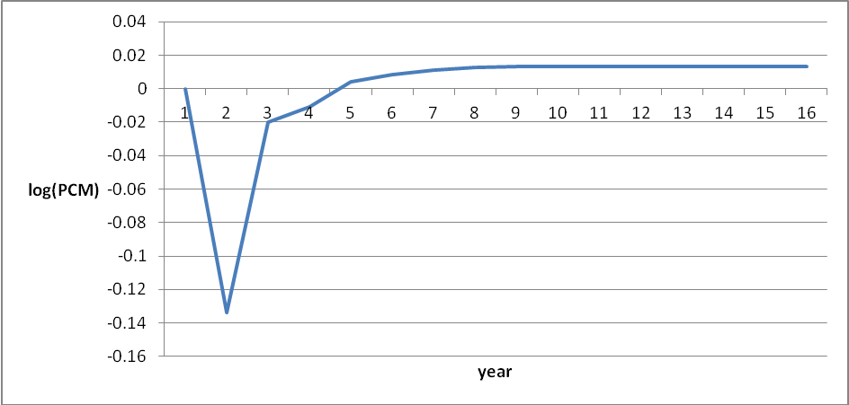

5.3 Robustness checks
We perform two robustness checks. First, we test the external validity of our previous findings by replicating the same analysis for a comparable dataset of French firms which has been extracted from the AMADEUS dataset. Even within this dataset, we find a significant negative impact of CH_IP, which ranges between -0.05 and -0.074 according to the chosen set of controls. In the long-run the coefficient is not significant.

Table 6: System GMM for the French dataset
 | (1) | (2) | (3) | (4) | (5) | (6) | (7)
VARIABLES | PCM | PCM | PCM | PCM | PCM | PCM | PCM
L.lPCM | 0.312*** | 0.309*** | 0.309*** | 0.321*** | 0.309*** | 0.221*** | 0.288***
 | (0.008) | (0.008) | (0.008) | (0.012) | (0.012) | (0.018) | (0.015)
L2.lPCM | 0.098*** | 0.095*** | 0.095*** | 0.105*** | 0.100*** | 0.097*** | 0.104***
 | (0.006) | (0.006) | (0.006) | (0.011) | (0.011) | (0.011) | (0.011)
CH_IP | 0.070*** | -0.052*** | -0.071*** | -0.068*** | -0.075*** | -0.074*** | -0.066***
 | (0.011) | (0.009) | (0.008) | (0.012) | (0.011) | (0.011) | (0.012)
L.CH_IP | -0.059*** | 0.051*** | 0.068*** | 0.065*** | 0.073*** | 0.079*** | 0.066***
 | (0.002) | (0.002) | (0.002) | (0.002) | (0.002) | (0.002) | (0.002)
CH_IP - LONG RUN | .0196*** | -.0026 | -.0056* | -.0055* | -.0035 | .0079 | -.0008
 | (.0019) | (.0019) | (.0021) | (.0025) | (.0023) | (.0020) | (.0025)
L.C4 |  |  | 0.053*** | 0.045*** | 0.052*** | 0.027*** | 0.031***
 |  |  | (0.008) | (0.009) | (0.009) | (0.008) | (0.009)
L.K_intensity |  |  |  | 0.028*** | 0.046*** | 0.027*** | 0.016***
 |  |  |  | (0.002) | (0.002) | (0.001) | (0.001)
L.size |  |  |  | -0.002** | 0.001 | 0.005*** | -0.001
 |  |  |  | (0.001) | (0.001) | (0.001) | (0.001)
L.unit_input |  |  |  |  | -0.061*** | -0.108***
 |  |  |  |  | (0.003) | (0.006)
L.lp |  |  |  |  |  | 0.197*** | 0.078***
 |  |  |  |  |  | (0.015) | (0.008)
L.lTOT_IP |  |  | 0.013*** | 0.009*** | -0.000 | -0.007*** | 0.009***
 |  |  | (0.002) | (0.002) | (0.002) | (0.002) | (0.002)
Year dummies | Yes | Yes | Yes | Yes | Yes | Yes | Yes
Sector dummies | No | Yes | Yes | Yes | Yes | Yes | Yes
Observations | 267,121 | 267,121 | 267,091 | 156,079 | 155,598 | 155,598 | 156,079
Number of firm | 59,746 | 59,746 | 59,738 | 45,542 | 45,447 | 45,447 | 45,542
ar2 | -0.916 | -0.636 | -0.868 | -0.405 | -0.264 | -0.135 | -0.386
ar2p | 0.360 | 0.525 | 0.385 | 0.686 | 0.792 | 0.893 | 0.699
j | 19 | 39 | 41 | 43 | 44 | 45 | 44
Robust standard errors in parentheses
*** p<0.01, ** p<0.05, * p<0.1

As a second check, we implement the previous estimation by adding 3-digits NACE sector dummies instead of 2-digits. In this way we account for sector trends at a much more refined level. The shortcoming related to this choice is the loss of a considerable amount of variability upon which we can estimate CH_IP impact. Results are shown in Table 7. The use of NACE 3-digit seems to mitigate the CH_IP short-run estimated impact both in terms of size and of statistical significance: the CH_IP looses significance when we start adding firm controls. The long run impact remains however positive and significant across all specifications.

Table 7: System GMM specifications with 3-digit NACE sector dummies
 | (1) | (2) | (3) | (4) | (5) | (6) | (7) | (8) | (9)
VARIABLES | lPCM | lPCM | lPCM | lPCM | lPCM | lPCM | lPCM | lPCM | lPCM
L.lPCM | 0.257*** | 0.198*** | 0.197*** | 0.198*** | 0.198*** | 0.197*** | 0.185*** | 0.064** | 0.175***
 | (0.010) | (0.011) | (0.011) | (0.011) | (0.011) | (0.016) | (0.017) | (0.029) | (0.021)
L2.lPCM | 0.121*** | 0.070*** | 0.070*** | 0.070*** | 0.071*** | 0.075*** | 0.074*** | 0.090*** | 0.090***
 | (0.007) | (0.008) | (0.008) | (0.008) | (0.008) | (0.012) | (0.011) | (0.011) | (0.011)
CH_IP | -0.155*** | -0.036*** | -0.037*** | -0.037*** | -0.032*** | -0.014 | 0.001 | 0.008 | -0.016
 | (0.014) | (0.011) | (0.011) | (0.011) | (0.011) | (0.014) | (0.013) | (0.013) | (0.013)
L.CH_IP | 0.184*** | 0.048*** | 0.048*** | 0.048*** | 0.043*** | 0.027* | 0.010 | 0.003 | 0.029**
 | (0.003) | (0.002) | (0.002) | (0.003) | (0.003) | (0.004) | (0.004) | (0.004) | (0.004)
CH_IP –LONG RUN | .0456*** | .0159*** | .0151*** | .0151*** | .0151*** | .0175*** | .0149*** | .0128*** | .0173***
 | (.0022) | (.0034) | (.0035) | (.0035) | (.0035) | (.0041) | (.0039) | (.0031) | (.004)
L.C4 |  |  | -0.051*** | -0.051*** | -0.049*** | -0.031** | -0.021* | -0.016 | -0.031**
 |  |  | (0.011) | (0.011) | (0.011) | (0.013) | (0.013) | (0.012) | (0.013)
L.TOT_IP |  |  | 0.001 | 0.001 | 0.001 | 0.001 | -0.001 | -0.000 | 0.002
 |  |  | (0.002) | (0.002) | (0.002) | (0.002) | (0.002) | (0.002) | (0.002)
 |  | (0.063) | (0.063) | (0.063) | (0.063) | (0.077) | (0.069) | (0.062) | (0.076)
 |  | (0.035) | (0.035) | (0.035) | (0.035) | (0.041) | (0.037) | (0.035) | (0.041)
L.exit |  |  |  | 0.044 | 0.034 | -0.011 | -0.010 | -0.011 | -0.011
 |  |  |  | (0.028) | (0.028) | (0.040) | (0.040) | (0.040) | (0.040)
L.entry |  |  |  | -0.004 | -0.007 | -0.033 | -0.024 | -0.024 | -0.036
 |  |  |  | (0.018) | (0.018) | (0.026) | (0.026) | (0.026) | (0.026)
L.V_IP |  |  |  |  | -0.174
 |  |  |  |  | (0.167)
L.K_intensity |  |  |  |  |  | 0.011*** | 0.032*** | 0.009*** | -0.003
 |  |  |  |  |  | (0.002) | (0.002) | (0.002) | (0.002)
L.size |  |  |  |  |  | -0.019*** | -0.030*** | -0.010*** | -0.009***
 |  |  |  |  |  | (0.001) | (0.002) | (0.001) | (0.002)
L.unit_input |  |  |  |  |  |  | -0.076*** | -0.155***
 |  |  |  |  |  |  | (0.004) | (0.012)
L.lp |  |  |  |  |  |  |  | 0.264*** | 0.079***
 |  |  |  |  |  |  |  | (0.026) | (0.012)
Year Dummies | Yes | Yes | Yes | Yes | Yes | Yes | Yes | Yes | Yes
Sector Dummies | Yes | Yes | Yes | Yes | Yes | Yes | Yes | Yes | Yes
Observations | 236,152 | 236,152 | 235,798 | 235,660 | 235,660 | 154,424 | 154,424 | 154,424 | 154,424
Number of firm | 67,200 | 67,200 | 67,100 | 66,962 | 66,962 | 53,647 | 53,647 | 53,647 | 53,647
ar2 | -2.874 | 0.553 | 0.541 | 0.529 | 0.475 | 1.086 | 0.944 | 0.667 | 0.614
ar2p | 0.00405 | 0.581 | 0.588 | 0.597 | 0.635 | 0.278 | 0.345 | 0.504 | 0.539
j | 19 | 108 | 110 | 110 | 113 | 112 | 113 | 114 | 113
Robust standard errors in parentheses
*** p<0.01, ** p<0.05, * p<0.1
5.3 Accounting for heterogeneity
Until now we implicitly assumed that the impact of Chinese imports on PCMs is homogeneous across firms. Nevertheless, this hypothesis might be too strong to provide a comprehensive picture of transformation brought about by the increasing Chinese competitive pressure: therefore we investigate whether, on the contrary, some firms have been hit more (less) by Chinese competitive pressure or react to it with a more (less) remarked quality-upgrading, on the basis of observable firms-characteristics. In particular, it may be interesting to test whether the impact may vary according to different levels of productivity. We can do it by interacting the current and lagged levels of CH_IP with a measure of productivity. We use two different measures: labor productivity and Total Factor Productivity (TFP) on value added. The latter indicator have been estimated using the technique developed by Levinsohn and Petrin (2003). We include the same set of firm’s controls used in the previous analysis. The default control of productivity, i.e. labor productivity has been substituted by TFP itself. Firm level productivities have been firstly transformed in logarithms and secondly differenced from the median level before being interacted with Chinese import penetration. Thus, the main coefficients derived from CH_IP and L.CH_IP should be interpreted as the short/long run impact for the firm being the median observation for the accounted variable. Concerning the IV strategy, the set of instruments have been integrated by adding interactions between firms characteristics and the same instruments which have been described before. Synthetic results of the full System GMM estimation (col. (8) of Table 5) have been showed in Table 8.
Table 8: CH_IP impact accounting for differences in productivity
 | Labor Productivity | TFP
L.PCM | 0.29399*** | 0.29518***
L2.PCM | 0.1267*** | 0.1285***
CH_IP | -0.0351*** | -0.0265**
L.CH_IP | 0.0523*** | 0.0434***
INTERACTION | 0.0616*** | 0.0829***
L.INTERACTION | -0.0582*** | -0.0801***
CH_IP - LONG RUN | 0.0296*** | 0.0292***
INTERACTION - LONG RUN | 0.0056*** | 0.0048**

The positive interaction term suggests that most productive firms are expected to be less hit by Chinese product. This effect is mitigated in the long-run, even though it still appear as significantly positive. In order to obtain a better intuition of the implications of the aforementioned coefficients, in Figure 4 and 5 we replicate the methodology of Figure 3 according to different levels of productivity. In particular, we calculate the impact of CH_IP according to five percentiles of the productivity distribution: the bottom 1% percentile, the bottom 10% percentile, the median, the top 90% percentile, and the top 99%. It clearly emerges how the expected dynamic pattern of reaction a of an import penetration shock results to be vary significantly according to the firm position within the productivity distribution.
Figure 4: CH_IP impact on PCM according to percentiles within TFP distribution 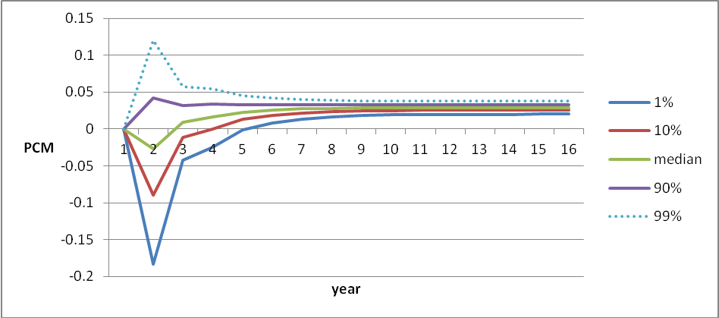
Figure 5: CH_IP impact on PCM according to percentiles within labor productivity distribution
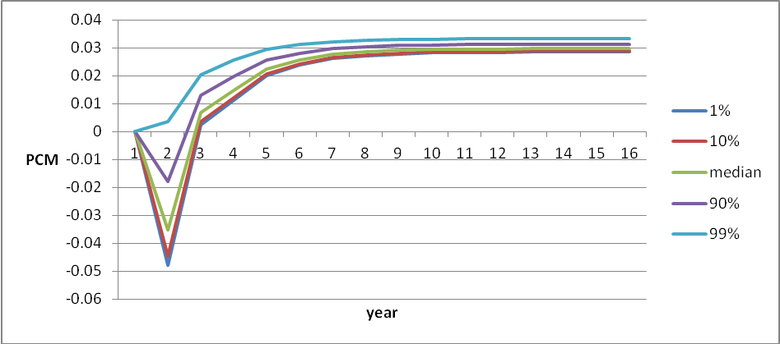

6. Conclusions
This paper empirically measures the competitive impact of Chinese import penetration on European firms’ price cost margins. The instrumental variables set, based on Chinese imports penetration of in the U.S.A., Japan and Korea, has been designed in order to be highly reactive to drivers of Chinese competitive pressure (being these countries the main OECD commercial partners of China), but at the same time exogenous with respect to local sources of endogeneity. These instruments result to correct downwards the coefficients estimated within the OLS framework, yielding results which are meaningful both in terms of economic prior and related empirical research.
While on the short-run there is strong evidence of a remarkable pro-competitive impact, on the long-run a mild (but statistically significant) positive effect on PCMs can be detected, which suggests a relevant process of product switching and quality-upgrading. This suggests that the commonly believed effect of markups squeezing due to low-wage competitive pressure is mainly temporary. Furthermore, the impact of Chinese import penetration is not homogenous across firms: in particular the most efficient firms are the ones which are expected to upgrade as a reaction to increased low-wage imports. Therefore, an open issue which would call for further research is the investigation on the exogenous drivers of heterogeneous response to import penetration, and the development of appropriate methodologies in order to empirically identify them.

References
Altomonte, C., Nicolini, M., Ogliari, L., & Rungi, A. (2009). Assessing the Competitive Behaviour of Firms in the Single Market: A Micro-based Approach. Study for DG Economic and Financial Affairs ECFIN/407/2008/516513 .
Auer, R., & Fischer, A. M. (2010). The effect of competition on U.S. inflationary pressure. Journal of Monetary Economics 57(4) , 491-503.
Auer, R., Degen, K., & Fischer, A. M. (2010). Globalization and inflation in Europe. Discussion Paper No. 8130, Centre for Economic Policy Research .
Baldwin, J., & Gu, W. (2009). The Impact of Trade on Plant Scale, Production-Run Length and Diversification. Chicago: University of Chicago Press.
Bernard, A. B., Jensen, J., & Schott, P. (2006). Survival of the Best Fit: Expo-sure to Low Wage Countries and the (Uneven) Growth of US Manufacturing Plants”. Journal of International Economics, , vol. 68, pp. 219-237.
Bernard, A., Eaton, J. B., Jensen, B., & Kortum, S. (2003). Plants and Productivity in International Trade. American Economic Review 93(4) , 1268-1290.
Boulhol, H. (2010). Pro-competitive effect of trade and non-decreasing price-cost margins. Oxford Bulletin of Economics and Statistics vol. 72(3) , 326-356.
Brenton, P., Pinna, A. M., & Vancauteren, M. (2000). Adjustment to Globalisation: A Study of the Footwear Industry in Europe. CEPS Working Documents 151 .
Bugamelli, M., Fabiani, S., & Sette, E. (2010). The pro-competitive effect of imports from China. Bank of Italy Working Paper 737 .
Cameron, A. C., & Trivedi, P. K. (2005). Microeconometrics. Methods and Applications. Cambridge University Press, New York
Chen, N., Imbs, J., & Scott, A. (2009). The dynamics of trade and competition. Journal of International Economics , 77(1): 50-62.
di Giacinto, V., & Micucci, G. (2009). Il miglioramento qualitativo delle produzioni italiane: evidenze da prezzi e strategie delle imprese. Bank of Italy Working papers .
Eckel, C., & Neary, P. (2009). Multi-Product Firms and Flexible Manufacturing in the Global Economy. Review of Economic Studies 77:1 , 188-217.
Fernandez, A. M., & Paunov, C. (2009). Does tougher import penetration foster quality upgrading? . World Bank Policy Research Working Paper 4894 .
Iacovone, L., & Javorcik, B. (2008). Multi-product Exporters: Diversification and Micro-level Dynamics. World Bank Working Paper No. 4723 .
Kleibergen, F. (2007). Generalizing weak instrument robust statistics towards multiple parameters, unrestricted covariance matrices and identification statistics. Journal of Econometrics vol. 139 , 181-216.
Levinsohn, J. (1993). Testing the Imports-as-Market-Discipline Hypothesis. Journal of International Economics, vol. 35 , 1-22.
Levinsohn, J., & Petrin, A. (2003). Estimating Production Functions Using Inputs to Control for Unobservables. The Review of Economic Studies .
Martin, J., & Méjean, I. (2011). Low-Wage Countries' Competition, Reallocation Across Firms and the Quality Content of Exports.
Melitz, M. (2003). The Impact of Trade on Intra-Industry Reallocations and Aggregate Industry Productivity. Econometrica, vol. 71 , 1265-1725.
Melitz, M., & Ottaviano, M. (2008). Market size, trade and productivity”. Review of Economic Studies 75 , 295-316.
Monfort, P., Vandenbussche, H., & Forlani, E. (2008). Chinese Competition and Skill-upgrading in European Textiles: Firm-level Evidence. Discussion Paper, Catholic University of Louvain .
Pietrobelli, C., & Rabellotti, R. (2006). Upgrading to Compete: Global Value Chains, Clusters, and SMEs in Latin America. Inter-American Development Bank .
Raff, H., & Wagner, J. (2009). Intra-Industry Adjustment to Import Competition: Theory and Application to the German Clothing Industry. Kiel Working Paper 1557 .
Tybout, J. (2003). Plant- and Firm-level Evidence on the New Trade Theories. Handbook of International Trade, Oxford: Basil-Blackwell .
WTO (2012). World Trade Report 2012.
Appendix
Table A.1 Aggregate Chinese imports in OECD countries in 2007
Korea, Republic of | 60.57
USA | 52.65
Japan | 48.68
Spain | 14.58
Germany | 10.87
Italy | 10.30
United Kingdom | 8.76
Australia | 7.24
Canada | 5.91
France | 5.62
Mexico | 3.48
Chile | 1.49
New Zealand | 1.19
Notes: all non-European countries and top five European importers have been included. Billions of USD. Data sourced from BACI

We limit the analysis to this time period as trade data for 2008 and 2009 are heavily affected by the global economic crisis (WTO, 2012).
This measure is not free from shortcomings as it implicitly assumes that the unit labor and material costs are flat with respect to output.
As a matter of fact, running the main specification described in this paper using Herfindal-Hirscham index instead of C4 yields no noticeable change to final results. That is not surprising, since the coefficient of correlation between the two concentration indexes is around 85%.
Data collected from the MICRO-DYN Centralized Database, available at http://micro-dyn.eu/
See Table A.1 in the Appendix.
In Figure 4, results from the top 1% percentile might appear rather counterintuitive. This might be explained by the fact of being outlier firm values: namely, firms outside the 1% are 318.

