 | 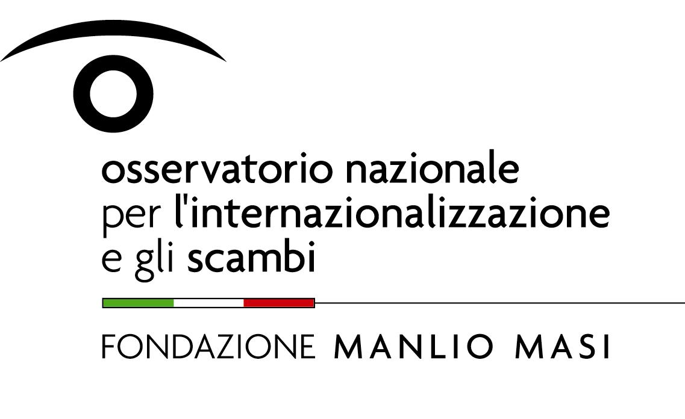
Dipartimento di Scienze Economiche e Sociali

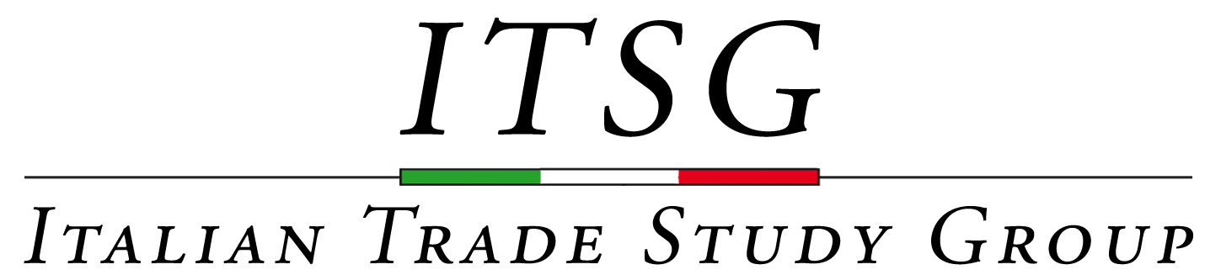

CALL FOR PAPERS

International Trade, Firms and Products

Department of Economics and Social Sciences,

Università Politecnica delle Marche, Ancona

June 13-14, 2013
The next meeting of the “ITSG - Italian Trade Study Group” will be organised by the Università Politecnica delle Marche and Fondazione Manlio Masi and hosted by the Department of Economics and Social.
Submissions are invited on all topics in international trade. Papers on multiproduct firm behavior in open economies are particularly welcome.
Choice of topics must be in the area of trade. Topics of special interest include:
- Trade and product quality upgrading
- Firm Internationalization and innovation
- Networks effects in trade, FDI, migrations
- Finance and trade
- Trade policy and development
- Multiproduct firms: models and empirics
- Trade in tasks and the labour market

Keynote speaker: Eric Verhoogen (Columbia University).

Complete papers (or advanced drafts) should be submitted to the Segreteria Fondazione Masi - segreteria.fondazionemasi@ice.it - by April 12th. The acceptance of the papers will be notified no later than May 6th.

The Scientific Committee of this meeting includes: Giuseppe De Arcangelis (Sapienza University of Rome), Paolo Epifani (Bocconi University), Giorgia Giovannetti (University of Florence), Alessia Lo Turco (Polytechnic University of Marche), Daniela Maggioni (Polytechnic University of Marche), Alessandro Sterlacchini (Polytechnic University of Marche), Lucia Tajoli (Politecnico di Milano).
Logistic information about the meeting will be posted in due time on the following website: www.fondazionemasi.it

