the determinants of inward foreign direct investment in business services across european regions

by

D. Castellani (University of Perugia), V. Meliciani (University of Teramo) and L. Mirra (University of Rome Tor Vergata)

Paper submitted to the italian trade study group, international trade, firms and organizations, department of economics, 29-30 november

abstract
The paper accounts for the determinants of inward foreign direct investment in business services across the EU-27 regions. Together with the traditional variables considered in the literature (market size, market quality, agglomeration economies, labour cost, technology, human capital), we focus on the role of forward linkages with manufacturing sectors and other service sectors as attractors of business services FDI at the regional level. This hypothesis is based on the evidence that the growth of business services is mostly due to increasing intermediate demand by other services industries and by manufacturing industries and on the importance of geographical proximity for forward linkages in services.
To our knowledge, there are no studies investigating the role of forward linkages for the location of FDI. This paper aims therefore to fill this gap and add to the FDI literature by providing a picture of the specificities of the determinants of FDI in business services at the regional level.
The empirical analysis draws upon the database fDi Markets, from which we selected projects having as a destination NUTS 2 European regions in the sectors of Business services over the period 2003-2008. Data on FDI have been matched with data drawn from the Eurostat Regio database. Forward linkages have been constructed using the OECD Input/Output database.
By estimating a negative binomial model, we find that regions specialised in those (manufacturing) sectors that are high potential users of business services attract more FDI than other regions. This confirms the role of forward linkages for the localisation of business service FDI, particularly in the case of manufacturing.

Keywords: FDI, Business Services, Regional Specialisation, Forward linkages.
JEL Codes: R12, L80, F23

- Introduction

Advanced economies, and Europe in particular, have seen a sharp increase in the internationalisation of services in the last two decades. In particular in the EU 27 services provided by far the largest contribution to inward stocks of Foreign Direct Investment (FDI) at the end of 2008 (83%) with business services (BS) representing a share of about 25% of total FDI in services (Eurostat, 2012).
The increasing share of business services in employment, production and trade and their role in the process of reorganisation of the ways in which goods and services are produced, delivered and traded both within and across countries has given rise to a rich literature on the determinants and the economic impact of these activities (Shearmur and Doloreux, 2008; Meliciani and Savona, 2011; Antonelli, 1998; Rubalcaba and Kox, 2007). In particular several studies have emphasised the positive effects that BS, and more specifically Knowledge Intensive Business Services (KIBS), have on the rest of the economy via the diffusion of specialized and knowledge intensive inputs (Antonelli, 1999; Greenhalgh and Gregory, 2000; Guerrieri et al. 2005; Baker, 2007; Camacho and Rodriguez, 2007a and 2007b; Kox and Rubalcaba, 2007a and 2007b; Evangelista et al. 2012).
Despite the increasing internationalisation of BS and the potential impact of these activities on innovation and growth, the literature on the location of multinational firms has mostly focussed on the manufacturing sector (Head, Ries and Swenson (1999), Basile (2004), Basile, Castellani and Zanfei (2008), Basile, Benfratello and Castellani (2006), Head and Mayer (2004), Amiti and Javorcik (2008), Mayer, Mejean, and Nefussi (2007).
Only recently some studies have compared the location determinants of manufacturing and service sectors and of production and service functions (Py and Hatem, 2011) finding that the location of service sectors and of service functions is more sensitive to market size, skilled-labor resources, and cultural proximity than the location of manufacturing sectors and production plants. Other studies have investigated the location determinants of service functions within the manufacturing sector (Defever, 2006, 2008) finding that within firm vertical linkages push firms to co-locate their service functions in countries where the firm has already a production plant.
Differently from previous research, the aim of our paper is to investigate the specificities in the location determinants of a particular branch of services, business services, considering their special nature of being “intermediate” activities.
FDI in business services, via the diffusion of specialized and knowledge intensive inputs, may contribute to enhance innovation and growth at the regional level, therefore, disentangling the factors that drive the localisation of these activities can help understanding processes of uneven growth of European regions and appropriately targeting industrial and innovation policy at the sub-national level.
Several authors have argued that the rise of services, particularly of business services, over the last thirty years is mostly due to changes in the production processes in many sectors and to the ensuing increase in the demand for services as intermediate goods (Francois, 1990; Rowthorn and Ramaswamy, 1999; Guerrieri and Meliciani, 2005; Savona and Lorentz, 2005; Francois and Woerz, 2008). The growth of BS has been favoured by the development and diffusion of Information and Communication Technologies (ICT) that have affected the linkages between manufacturing and service industries, on the one hand by increasing the service content of many manufacturing activities, and on the other by facilitating the “splintering” away of activities once performed inside manufacturing firms, thus favouring the fragmentation of production also across national borders.
However, despite the increasing tradability of services, many studies have shown that geographical proximity with users is still an important determinant of services location choices. In particular Combes (2000), van Oort (2007) and Burger et al. (2008) find that localisation externalities are more positively related to services than to other sectors' employment growth, arguing that services benefit more from concentration than other economic activities. Moreover Antonietti and Cainelli (2008) find that spatial agglomeration - where the probability of finding specialised external providers, face-to-face contacts and close spatial interaction is high- positively affects the location of business services in Italy.
Finally, and mostly relevant to our study, Nefussi and Schwellnus (2010) show the existence of a complementarity between the location of business services and manufacturing activities of French affiliates abroad while Meliciani and Savona (2011) find that intermediate demand from the manufacturing sector positively affects domestic specialisation in BS at the regional level (across EU 27 NUTS 2 regions).
The results of these studies suggest that the location choices of multinationals in BS can be affected by the sectoral composition of domestic economies, an issue that has been unexplored so far by the literature. This paper contributes to the literature by providing a picture of the specific role played by forward domestic linkages for the localisation of FDI in business services at the regional level.
The empirical analysis draws upon the database fDi Markets, from which we selected projects having as a destination NUTS 2 European regions in the sector of Business services over the period 2003-2008. By estimating a negative binomial model, we find that regions specialised in those (manufacturing) sectors that are high potential users of business services attract more FDI than other regions.
The remainder of the paper is organised as follows: Section 2 describes the data on FDI in business services used in the analysis; Section 3 discusses the empirical specification; Section 4 describes the econometric methodology; Section 5 comments on the results of the empirical analysis; Section 6 presents the main conclusions and policy implications.

- FDI in business services across European regions
The empirical analysis draws upon the database fDi Markets which provides information on foreign direct investments projects starting from 2003. fDi Markets is an online database maintained by fDi Intelligence - a specialist division of the Financial Times Ltd - which monitors cross-border investments covering all sectors and countries worldwide. Relying on media sources and company data, fDi Markets collects detailed information on cross-border greenfield investments (available since 2003). Data are based on the announcement of the investment and updated daily (More information at http://www.fdimarkets.com/). For each project, fDi Markets reports information on the industry and main business activity involved in the project, the location where the investment takes place (host country, regions and cities), as well as the name and location of the investing company (home). The database is used as the data source in UNCTAD's World Investment Report and in publications by the Economist Intelligence Unit. For the purpose of this analysis we have selected projects having as a destination NUTS 2 European regions in the sector of Business services over the period 2003-2008. Figure 1 shows the localisation of these projects in a map.

(Figure 1 about here)

We can observe that the projects are mostly located in regions with capital cities or large urban centres (Inner London, Ile de France, Comunidad de Madrid, Cataluna, Region de Bruxelles, Southern Ireland, Bucuresti, Berlin, Lombardia, Lazio, etc.). Areas of high concentration also include the Northern part of UK and Ireland, the North-West part of Italy with some Southern regions of Germany, the Baltic republics. On the other hand areas with few or no investments include Greece, Southern Italy, Centre-Western France, Sweden and Finland (with the exception of regions where the capital cities are located). Eastern regions attract FDI in business services mostly around their capital cities.

3. Location determinants of inward FDI

The spatial distribution of inward FDI can be modeled as the result of the interaction between centripetal and centrifugal forces. As centripetal forces, in addition to focussing on the ‘usual suspects’, such as market size, R&D intensity, agglomeration economies, we investigate the linkages between business services and other service and manufacturing industries. Among the centrifugal forces, we consider the effect of labor costs, moderated by the level of human capital. The definition of all variables with the data sources are reported in Table 1.

3.1 Forward linkages between BS and other sectors
Our main explanatory variable is an index of forward linkages with other service and manufacturing industries, obtained as the weighted share of employment in manufacturing and service industries that are above average users of business services over total employment. In particular, we take a vector measuring the use of services on output for manufacturing/service sectors that are above average BS users and, for each region, we multiply it by total employment in each respective manufacturing/service sector; this number is then divided by the region’s i total employment:

$${\text{FL}}_{i}=\frac{\sum_{j=1}^{m}{W_{j}E_{\text{ij}}}}{\sum_{j=1}^{n}{E_{\text{ij}}}}$$

where:
i=region, j=sector, m=number of above average BS users manufacturing/service sectors, n=total number of sectors, E=employment, W=weight given by the average (across European countries) share of business services in total industry output as computed from Eurostat symmetric Input Output tables in 2005. The indicator is higher the higher is regional employment in manufacturing/service sectors that are strong users of BS with respect to total regional employment.
Table 2 reports the coefficients that are used as weights to construct our indicator. These are obtained by regressing the share of business services in total output on industry dummies for all European countries included in the analysis in the year 2005.
Consistently with Wood (2006) the table shows a high use of BS from other service sectors (6%). Services that are major users of BS are high-tech knowledge-intensive services (Computer and related services, R&D and Post and Communication) but also other less knowledge intensive services (e.g. Wholesale and retail trade). Looking at manufacturing sectors, we find that those making considerable use of business services are all (with the exception of Food, Beverages and Tobacco) high or medium-high technology industries (Printed matter and recorded media; Chemicals and chemical products; Office machinery and computers, Radio, television and communication equipment and apparatus; Medical, precision and optical instruments, watches and clocks; Other transport equipment; Electrical machinery and apparatus), while labour and scale-intensive industries appear, on average, to be low or medium users of business services. This pattern shows regularities across countries: this allows us to expect that our indicator, that uses as weights the mean coefficients for above-average BS user industries reported in Table 2, is a good proxy for ‘potential’ intermediate demand.
Figures 2 and 3 show in a map the position of the regions with respect to the indicators of forward linkages between business services and other high user services and between business services and high user manufacturing industries.

(Figures 2 and 3 about here)

Considering regions with a potential high demand for business services originating from other services, we can observe high values in Dutch and UK regions, in Southern Ireland and in many capital regions (Bucharest, Madrid, Lisbon, Prague, Ile de France, Vienna). Particularly low values are shown in regions located in Northern and Eastern countries and in several French and German regions.
Finally, considering potential intermediate manufacturing demand, high intermediate demand regions include again most UK and Irish regions but also Western Finland, Southern Sweden, some regions of Northern Italy, many German, Czech and Hungarian regions, some Central French regions (Haute Normandie, Centre and Ile de France) while highly despecialised regions include Greece, Southern Italy, Portugal, Western Spain and most Polish and Rumanian regions.
Descriptive statistics for these variables and all other variables used in the estimation are reported in Table 3.

  - Market size and ‘quality’
The size of regional market (measured by the logarithm of total value added) is intended to capture externalities related to the “home market effect”. As first noted by Krugman (1980), under increasing returns to scale and in the presence of transport costs, the appeal of a region as a production site depends crucially on the size of its domestic market. Firms locate in the region where they can exploit economies of scale to a greater extent, and, eventually, export to neighboring regions. Since business services are directed to relatively wealthy consumers, we also control for per-capita GDP as a measure of ‘quality’ of the market.

  - R&D intensity
R&D intensity (R&D expenditure as a share of GDP) are intended to capture the quality of innovation system, which can be a key determinant for locating high-value added activities, such as the business services we are considering in this work.

  - Agglomeration externalities
Since Hoover (1948), distinguishing between two sources of agglomeration externalities is common: a) economies external both to a firm and to sectors (the so-called urbanization externalities), b) economies external to a firm but internal to its sector (the so-called Marshallian externalities). In line with the literature, regions with higher population density (measured as total population per square km) would experience higher urbanization externalities and thus attract more inward FDI. Additionally, we expect that hosting the country capital would generate further urbanization externalities. Marshallian externalities are instead proxied by the service density in the region (the number of local units in business services per square km).

  - Labor market characteristics
The role of labor market characteristics as a determinant of inward FDI and new plant creation is well established (Friedman et al. 1992). We follow previous literature by specifying the regional labor market characteristics using two variables: the average wage (measured by total regional compensation to labor divided by the total number of employees in a region) and human capital endowment (measured by the share of regional population with tertiary education). The impact of wages is not univocal, however. Lower wages may attract firms pursuing cost reducing strategies, but high wages may signal highly skilled workers, which in turn attract the location of higher value added activities. However, conditional on a measure on human capital, we expect a negative effect of regional wages on inward investments.

- Econometric methodology
Since our dependent variable is the number of projects in BS received by each region, in the econometric analysis we use statistical models generally applied for estimating equations where the dependent variable has a discrete nature. These are applications and generalizations of the Poisson distribution. The Poisson probability function may be expressed as follows:

P(n)=exp(−λ)λ^{n} /n (1)

where n is the number of occurrences of the event and λ is the mean and the variance of the distribution. If we specify n as the number of FDI projects, we can make the parameter λ depend on a set of explanatory variables that we assume to affect the capability of European regions to attract FDI in business services:

λ_{i}= exp(βX_{i}) (2)

The coefficients can be estimated maximizing the log-likelihood function of the Poisson model. The main problem of the Poisson specification is that it imposes equality between the mean and the variance of the distribution. When this hypothesis is rejected by the data, i.e. the case of ‘overdispersion’, the Poisson model is inappropriate as it leads to an underestimation of the variance–covariance matrix. The negative binomial model is an extension of the Poisson model that allows the variance of the distribution to increase faster than the mean (Cameron and Trivedi, 1986). This model arises by specifying:

lnλ_{i}=βX_{i}+ε_{i} (3)

where exp(e) has a gamma distribution with mean one and variance α. A natural form of overdispersion is the following:

var(n) /E(n)=1+αE(n) (4)

where the Poisson model results from setting α = 0. We therefore estimate a negative binomial model if α is not significantly different from zero.
The set of independent variables includes all the factors that we expect affecting inward FDI (see Section 3, table 1). Robustness checks include introducing country dummies in the original specification and adding spatial lags of the exogenous variables.
The introduction of country dummies allows disentangling the contribution of the inter-regional variation in location characteristics, once the country-level variation is accounted for. As a matter of fact, a number of locational determinants have a significant cross-country variation, but a relatively limited cross-regional variation (within countries). In other words, country dummies will allow to disentangle the “regional” from the “country” effect. Controlling for spatial lags allows capturing possible inter-regional spillover effects in the determinants of inward FDI. Such effects are predicted by recent studies on European regions arguing that the ongoing process of trade liberalisation and unification has led to increasing similarities across neighbouring regions (foreign and domestic) and to a decreasing relevance of national borders (Overman and Puga, 2002).
In order to construct spatial lags we have to specify the spatial weight matrix. In the literature two main criteria are used to evaluate geographical connections: a contiguity indicator or a distance indicator. In the first case, it is assumed that interactions can only exist if two regions share a common border (the contiguity indicator can be refined by taking into account the length of this common border). The problem with the contiguity matrix is that some regions might not share borders with any other region (this is the case of islands). Therefore it doesn’t seem to be the best choice in our sample of European regions. We therefore rely on a distance-based matrix.
In the case of a distance matrix, it is assumed that the intensity of interactions depends on the distance between the regions. In defining a distance matrix various indicators can be used depending on the definition of the distance (great circle distance, distance by roads etc.) and depending on the functional form we choose (the inverse of the distance, the inverse of the squared distance etc.). Finally, a distance-cutoff above which spatial interactions are negligible must be chosen. Following, among others, Dall’Erba and Le Gallo (2008), we use the great circle distance between regional centroids. In particular each element of the spatial weight matrix is defined as follows:

w_{ij}=0 if i=j; w_{ij}=1/(d_{ij}^{k}) if d_{ij}<=D and w_{ij}=0 if d_{ij}>D

where w_{ij} is an element of the row standardised weight matrix W (with row standardisation spatially weighted variables represent an average across neighbouring regions); d_{ij} is the great circle distance between centroids of regions i and j; k defines the functional form and D is the cutoff parameter above which spatial interactions are assumed to be negligible. In the basic specification we take the inverse of the squared distance and we choose the median distance as a cut-off. We test for robustness using different distance bands.

- Empirical results
Table 4 reports the results of the estimation of equation (3) with various specifications. Column (1) includes only regional variables among the regressors; column (2) controls for possible differences in country characteristics by introducing country dummies; columns (3) and (4) control also for spatial lags of the explanatory variables respectively in the specification with and without country dummies.
In the specifications without country dummies most of the determinants of FDI highlighted in the literature show up significant and with the expected sign. In particular inward investments in business services increase with market size, with tertiary education and with agglomeration economies (captured by population density and by dummies for capital cities) and decreases with labour costs and with the density of employment in BS in previous years (once controlling for other variables capturing agglomeration economies the BS service density appears to capture the competition effect). The important role played by market size and by skills in attracting FDI in business services confirms the results found by Py and Hatem (2011) at the country level.
The presence of potential intermediate demand coming from the manufacturing sector also positively affects inward investment in business services while forward linkages with other services appear less important (they are significant only in the specification excluding spatial lags and only at 10%).
Overall, including spatial lags do not seem to affect the results significantly, although variables capturing agglomeration externalities become insignificant while the quality of demand (proxied by per capita GDP) becomes positive and significant. Among the spatial lags, only the quality of demand (per capita GDP) shows a robust and significant negative effect, suggesting the existence of negative externalities (a displacing effect) for those regions that are surrounded by regions with high quality demand.
When country dummies are introduced in the estimations, results change considerably with many variables becoming insignificant. Only market size and forward linkages with the manufacturing sector remain robust determinants of FDI in business services in both specifications (with and without spatially lagged variables). Dummies for regions where capital cities are located have a positive impact on FDI only when spatial effects are not controlled for, while per capita GDP is significant only in the specification including spatial lags. Finally, among spatially lagged variables, proximity to regions with a high manufacturing potential demand for BS seems to favour inward FDI in business services. Results are robust to computing spatial weights using different cutoffs (the first quartile, the third quartile and the maximum distance).
Overall these results suggest that some traditional determinants of FDI (in particular labour costs and human capital) are important location factors of investments in BS at the country level but they do not explain why a firm chooses a particular region within a country; this choice appears to be especially driven by overall demand (as proxied by value added) and by potential demand for BS coming from the manufacturing sector. These results are in line with the view that, despite the ICT revolution, the geographical proximity between users and producers is still a crucial factor for the location of services (Polèse and Shearmur, 2004; Antonietti and Cainelli, 2008).
Surprisingly synergies between other service industries and BS appear far less important (they show up significant only in the specification without country dummies and without spatial lags) than synergies between manufacturing industries and BS. A possible explanation of this result is that many inter-sectoral linkages between BS and other service sectors occur in large urban areas so that their effect is captured by the dummy on capital cities.

- Conclusions
This paper has investigated the determinants of FDI in business services across European regions. We have found that the localisation of such investments responds to the traditional factors also explaining FDI in manufacturing (cost advantages, demand, human capital and agglomeration economies). However, given the importance of intermediate demand for the growth of BS, we have also investigated whether proximity to potential user industries exerts a positive role in attracting foreign investments in business services. The results of the estimations (using different specifications) show a robust significant relationship between FDI in BS and the local (regional) presence of high users manufacturing sectors. This evidence is particularly interesting also considering that, in the specifications including country dummies, only market size and forward linkages with the manufacturing sector appear robust determinants of FDI in business services in all specifications.
The importance of local manufacturing intermediate demand for FDI in BS complements the finding of Nefussi and Schkellnus (2010) showing the existence of a complementarity between the location of business services and manufacturing activities of French affiliates abroad and those of Meliciani and Savona (2011) finding that intermediate demand from the manufacturing sector positively affects domestic specialisation in BS at the regional level.
The existence of a complementarity between foreign investments in BS and the local presence of some (high BS users) manufacturing industries supports the view that such services are not “footloose” (Wernerheim and Sharpe, 2003) and suggests that regional policies aiming at attracting business services might prove ineffective in the absence of a pre-existing local intermediate demand for such services.
Nefussi and Schkellnus (2010) observe that the complementarity between manufacturing and service FDI implies that offshore manufacturing leads to also offshore business services so that the option for advanced countries to delocalise production activities maintaining service activities at home might not be viable. Our results qualify this result by showing that what really matters for attracting FDI in business services is not manufacturing in general but the presence of some manufacturing industries that are high users of these services and these are mostly high and medium-high technology manufacturing industries. From a policy perspective this suggests the importance of platform policies based on related variety and differentiated knowledge bases (Asheim et al., 2011) not only for regional domestic development but also for the capability of attracting foreign investment.

References
Amiti, M., and B. S. Javorcik (2008). “Trade costs and location of foreign firms in China” Journal of Development Economics, 85(1-2), 129-149.
Asheim B, Boschma R and Cooke, P (2011) Constructing Regional Advantage: Platform Policies Based on Related Variety and Differentiated Knowledge Bases. Regional Studies 45(7): 893-904.
Antonelli, C., 1998. Localized technological change, new information technology and the Knowledge-Based Economy: the European evidence. J. Evolutionary Econ. 8(2), 177–198.
Antonelli, C., 1999. The Microdynamics of Technological Change. Routledge, London.
Antonietti R, Cainelli G (2008) Spatial agglomeration, technology and outsourcing of knowledge intensive business services. Empirical insights from Italy. International Journal of Service Technology and Management 10(2-4): 273-298.
Baker, D., 2007. The impact of business-services use on client industries: evidence from input output data, in: Rubalcaba, L., Kox, H. (Eds), Business Services in European Economic Growth, Palgrave MacMillan, New York, pp. 97-115.
Basile, R., 2004. Acquisition versus greenfield investment: the location of foreign manufacturers in Italy. Regional Science and Urban Economics 34, 3–25.
Basile R., Benfratello L. and Castellani D. (2012), Geoadditive models for regional count data: an application to industrial location. Geographical Analysis, forthcoming.
Basile, R., L. Benfratello, and D. Castellani. (2006). “Attracting Foreign Direct Investments in Europe: Are Italian Regions Doomed?” In Marco Malgarini and Gustavo Piga (eds.), Capital Accumulation, Productivity and Growth. Monitoring Italy 2005, Houndmills, Basingstoke and New York: Palgrave Macmillan, 319-354.
Basile, R., D. Castellani, and A. Zanfei. (2008). “Location Choices of Multinational Firms in Europe: the Role of National Boundaries and EU Policy.” Journal of International Economics 74, 328-340.
Blonigen, B.A., Davies, R.B., Waddell, G.R., Naughton, H.T. (2007), “FDI in space: Spatial autoregressive relationships in foreign direct investment”, European Economic Review, 51, 1303-1325.
Burger M J, van Oort F G, van der Knaap B (2008) A Treatise on the Geographical Scale of Agglomeration Externalities and the Modifiable Areal Unit Problem. Erasmus Research Institute on Management, ERS-2008-076.
Camacho, J.A., Rodriguez, M., 2007(a). Integration and diffusion of KIS for industry performance, in: Rubalcaba, L., Kox, H. (Eds), Business Services in European Economic Growth, Palgrave MacMillan, New York, pp. 128-143.
Camacho, J.A., Rodriguez, M., 2007(b). How important are knowledge-intensive services for their client industries? An assessment of their impact on productivity and innovation, in: Gallouj, F., Djellal, F. (Eds.), The Handbook of Innovation and Services, Elgar, Cheltenham, pp. 424-447.
Cameron, A. and Trivedi, K. (1986). ‘Econometric Models Based on Count Data: Comparisons and Applications of Some Estimators and Tests’, Journal of Applied Econometrics, Vol. 1, pp. 29–53.
Combes P P (2000) Economic Structure and Local Growth: France 1984-1993. Journal of Urban Economics 47: 329-353.
Dall'Erba S., J. Le Gallo (2008). “Regional convergence and the impact of European structural funds over 1989-1999: A spatial econometric analysis”, Papers in Regional Science, vol. 87(2), pages 219-244.
Defever, F. (2006). Functional fragmentation and the location of multinational firms in the enlarged Europe," Regional Science and Urban Economics, 36(5), 658-677.
Defever, F. (2008). Is it strategic to attract the service activities of multinational firms? Some empirical evidence. In S Brakman and H Garretsen (eds), Foreign Direct Investment and the Multinational Enterprise, 2008, MIT Press.
Evangelista, R., Lucchese, M., Meliciani, V., 2012, “Business services, innovation and sectoral growth”, Structural Change and Economic Dynamics, forthcoming.
Francois J F (1990) Producer services, scale, and the division of labor. Oxford Economic Papers 42: 715-729.
Francois, J., Woerz, J., 2008. Producer services, manufacturing linkages, and trade. Journal of Industry, Competition and Trade. 8(3), 199-229.
Friedman, J., D. Gerlowski, and J. Silberman. (1992). “What attract foreign multinational corporations? Evidence from branch plant location in the United States.” Journal of Regional Science 32, 403-418.
Greenhalgh, C., Gregory, M., 2000. Labour productivity and product quality: their growth and inter-industry transmission in the UK 1979-90, in: Barrell, R., Mason, G., O’Mahoney, M., (Eds.), Productivity, Innovation and Economic Performance. Cambridge University Press, Cambridge.
Guerrieri, P., Maggi, B., Meliciani, V., Padoan, P.C., 2005. Technology diffusion, services, and endogenous growth in Europe: is the Lisbon strategy useful?. IMF Working Paper WP/05/103, IMF Washington.
Guerrieri, P., Meliciani, V., 2005. Technology and international competitiveness: The interdependence between manufacturing and producer services. Structural Change and Economic Dynamics. 16(4), 489-502.
Head, K., and T. Mayer (2004). “Market Potential and the Location of Japanese Investment in the European Union”, The Review of Economics and Statistics, 86(4), 959-972.
Head, K., J. Ries, and D. Swenson (1999). “Attracting foreign manufacturing: Investment promotion and agglomeration”, Regional Science and Urban Economics, 29(2), 197-218.
Hoover, E. M. (1948). The Location of Economic Activity. New York: McGraw Hill.
Kox H., Rubalcaba L., 2007b. Business services and the changing structure of European economic growth. MPRA Paper n. 3570.
Kox, H., Rubalcaba, L., 2007a. Analysing the contribution of business services to European economic growth. MPRA Paper n. 2003.
Krugman, P. (1980). "Scale Economies, Product Differentiation, and the Pattern of Trade", American Economic Review, vol. 70(5), pages 950-59.
Mayer, T., I. Mejean, and B. Nefussi (2010). “The location of domestic and foreign production affiliates by French multinational firms", Journal of Urban Economics, 68(2), 115-128.
Meliciani, V. and M. Savona (2011), “Regional specialization in business services: agglomeration economies, vertical linkages and innovation”, SPRU Electronic Working Paper n. 193.
Muller E, Zenker A (2001) Business services as actors of knowledge transformation: the role of KIBS in regional and national innovation systems. Research Policy 30: 1501-1516.
Nefussi B, Schkellnus C (2010) Does FDI in manufacturing cause FDI in business services? Evidence from French firm-level data. Canadian Journal of Economics 43: 180-203.
Overman, H. G. and Puga, D. (2002) Unemployment clusters across Europe's regions and countries, Economic Policy 34, 115-147.
Polèse M, Shearmur R (2004) Is distance really dead? Comparing industrial location patterns over time in Canada. International Regional Science Review 27: 431–57.
Py, L. and F. Hatem, (2010), Internationalisation et localisation des services: une analyse sectorielle et fonctionnelle appliquée aux firmes multinationales en Europe, Economie et Statistique, 426, 67-95.
Rowthorn. R, Ramaswamy R (1999) Growth, Trade and Deindustrialisation. IMF Staff Papers 46, 18-41.
Rubalcaba, L., Kox, H. (Eds.), 2007. Business services in European economic growth. Palgrave MacMillan, New York.
Savona M, Lorentz A (2005) Demand and Technological Contribution to Structural Change and Tertiarisation. An Input-Output Structural Decomposition Analysis. LEM Working Paper Series, 2005/25 (December 2005).
Shearmur R, Doloreux D. (2008) Urban hierarchy or local buzz? High-order producer service and (or) knowledge-intensive business service location in Canada, 1991–2001. Professional Geographer, 60: 333–355.
Van Oort F G (2007) Spatial and sectoral composition effects of agglomeration economies in the Netherlands. Papers in Regional Science 86(1): 5-30.
Wernerheim M C and Sharpe C (2003) High Order Producer Services in Metropolitan Canada: How Footloose Are They? Regional Studies 37(5): 469-490.
Wood P (2006), Urban Development and Knowledge-Intensive Business Services: Too Many Unanswered Questions? Growth and Change, 37, 335–361.

Table 1. The description of the variables
Variable | Description | Source
Market size | Log of regional value added --- mean value over the period 1996-2007 | Eurostat
Per capita GDP | Log (regional GDP/population) --- mean value over the period 1996-2007 | Eurostat
Wages | Log (wages/Total employment) --- mean value over the period 1995-2006 | Eurostat
R&D intensity | Log (regional intramural R&D expenditure in all sectors /regional GDP) --- mean value over the period 2003-2010 | Eurostat
Human capital | Log (population with tertiary education/regional population) --- mean value over the period 1995-2010 | Eurostat
Population density  Country capital | Log (Regional population/ regional area measured in Km²) --- mean value over the period 1997-2008  Dummy for regions where capita cities are located | Eurostat
Service density | Log (number of local units in business services/regional area in 2005 measured in Km² --- mean value over the period 1998-2002 | Eurostat
Forward linkages with manufactures | Weighted share of employment in manufacturing industries that are above average users of business services over total employment | Eurostat/OECD Input-Output database
Forward linkages with other services | Weighted share of employment other service industries that are above average users of business services over total employment | Eurostat/OECD Input-Output database
Table 2. Share of Business Services in total industry output in 2005, average across European countries
Above average  manufacturing Industries | Share | Above average service industries | Share
Tobacco products | 8.2% | Computer and related services | 10.1%
Printed matter and recorded media | 6.9% | Wholesale trade and commission trade, except of motor vehicles and motorcycles | 8.6%
Chemicals and chemical products | 5.4% | Renting of machinery and equipment without operator and of personal and household goods | 7.6%
Office machinery and computers | 4.4% | Research and development services | 7.5%
Other transport equipment | 4.3% | Insurance and pension funding services, except compulsory social security services | 7.2%
Food products and beverages | 4.3% | Retail trade services, except of motor vehicles and motorcycles; repair services of personal and household goods | 6.8%
Electrical machinery and apparatus n.e.c. | 4.1% | Sale, maintenance and repair of motor vehicles and motorcycles; retail sale of automotive fuel | 6.1%
Radio, television and communication equipment and apparatus | 4.1% | Post and telecommunications services | 6.1%
Medical, precision and optical instruments, watches and clocks | 4.0%
Average | 3.8% | Average | 6.0%
Source: Eurostat input-output tables

Table 3. Descriptive statistics
Variable | Obs | Mean | Std Dev | Min | Max
FDI in business services | 173 | 5.88 | 17.80 | 0.00 | 184
Market size (millions of euros) | 173 | 40104.54 | 44618.33 | 3958.78 | 386418.70
Per capita GDP (annual PPS per inhabitants) | 173 | 19490.90 | 7808.69 | 4483.33 | 64158.33
Wages per employee | 173 | 22000.29 | 11.22 | 1.58 | 72.17
R&D expenditure (% of GDP) | 173 | 1.51 | 1.18 | 0.11 | 5.50
Human Resources in Science and Technology - Education (% of regional employment) | 173 | 16.41 | 6.31 | 6.11 | 35.43
Population density (number of inhabitants per Km²) | 173 | 393.74 | 961.16 | 3.29 | 8950.74
Service density ( number of local units in business services/regional area in 2005in Km²) | 173 | 3.85 | 16.37 | 0.02 | 154.40
Forward linkages with manufacture | 173 | 1.54 | 0.67 | 0.25 | 3.62
Forward linkages with other services | 173 | 14.01 | 4.00 | 5.37 | 28.51

Sources: FDI markets and Eurostat

Table 4. Location determinants of FDI in business services: regression results
Variables | (1) | (2) | (3) | (4)
Value added  Per capita GDP  Wages  R&D intensity  Human capital  Population density  Service density  Country Capital  Forward linkages with manufactures  Forward linkages with other services  Lagged VA  Lagged GDP  Lagged wages  Lagged R&D  Lagged human capital  Lagged population density  Lagged service density  Lagged Country Capital  Lagged manufacturing linkages  Lagged service linkages | 1.144***  (0.123)  0.897  (0.637)  -1.648***  (0.312)  -0.186  (0.131)  1.033***  (0.309)  0.357**  (0.145)  -0.297*  (0.162)  1.136***  (0.287)  0.704***  (0.209)  0.839*  (0.504) | 1.480***  (0.212)  1.109  (1.159)  -0.590  (0.962)  -0.040  (0.192)  0.820  (0.995)  0.402  (0.619)  -0.470  (0.635)  0.793**  (0.374)  0.426*  (0.237)  0.354  (0.681) | 1.305***  (0.139)  2.003***  (0.747)  -1.777***  (0.477)  -0.163  (0.152)  0.891*  (0.510)  0.216  (0.258)  -0.178  (0.246)  0.452  (0.356)  0.591**  (0.238)  0.222  (0.539)  -0.051  (0.679)  -5.543**  (2.346)  1.997*  (1.107)  0.107  (0.344)  -0.823  (1.142)  -0.033  (0.393)  -0.123  (0.391)  0.041  (1.119)  0.428  (0.641)  2.266  (1.985) | 1.579***  (0.231)  1.882***  (1.38)  -0.968  (1.180)  -0.146  (0.181)  -0.039  (1.061)  -0.072  (0.722)  0.034  (0.701)  0.451  (0.369)  0.530**  (0.268)  0.230  (0.713)  -0.068  (0.951)  -4.665*  (2.798)  1.367  (1.338)  -0.696  (0.498)  -1.346  (1.503)  -0.409  (0.478)  0.096  (0.430)  0.051  (1.561)  2.114*  (1.237)  0.967  (1.945)
Notes: (1) is the basic specification; (2) includes also country dummies (coefficients not reported); (3) includes spatial lags; (4) includes spatial lags and country dummies; *,**,*** denote significant at respectively 10, 5 and 1%.

Figure 1. Inward Foreign Direct Investments in business services
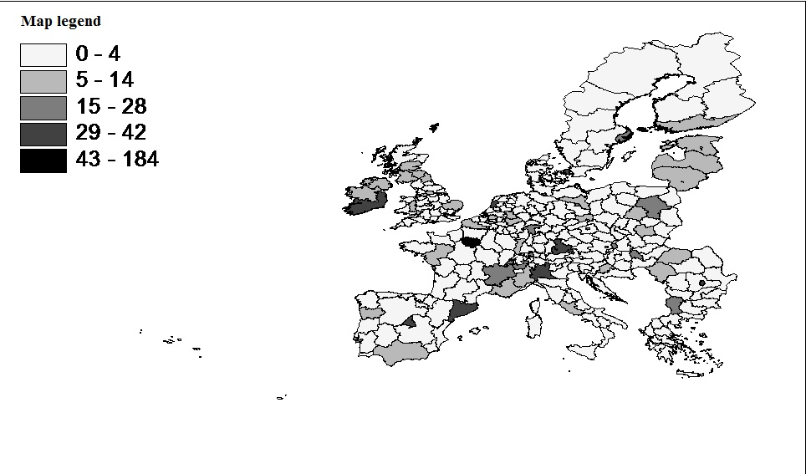

Figure 2. Potential intermediate demand (forward linkages) from other services (quartiles)

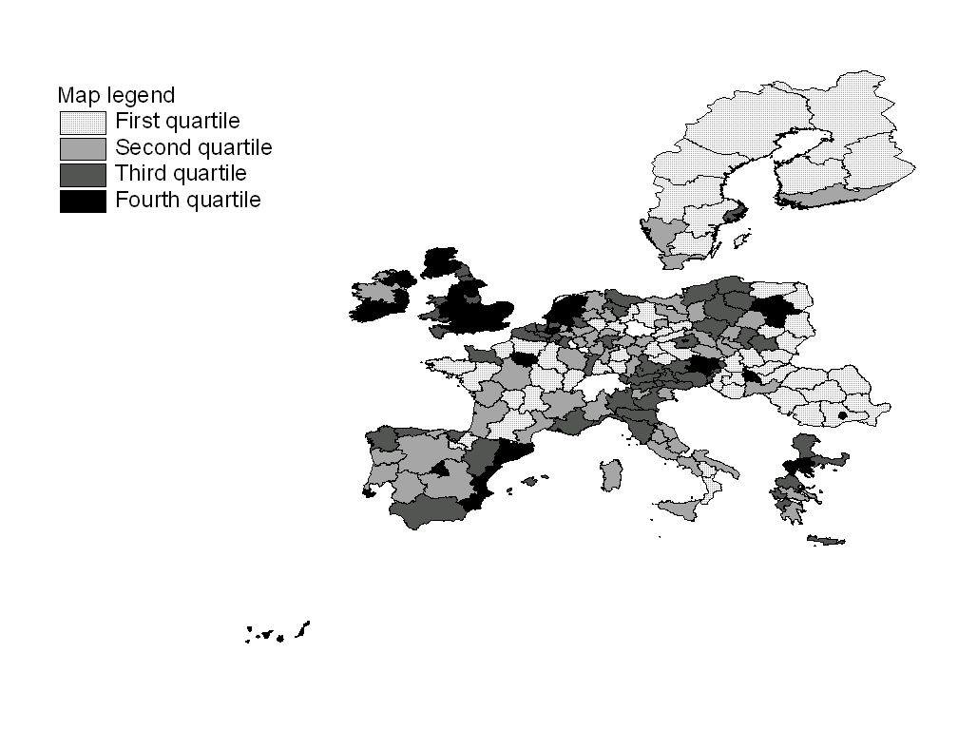
Figure 3. Potential intermediate demand (forward linkages) from manufacturing industries (quartiles)

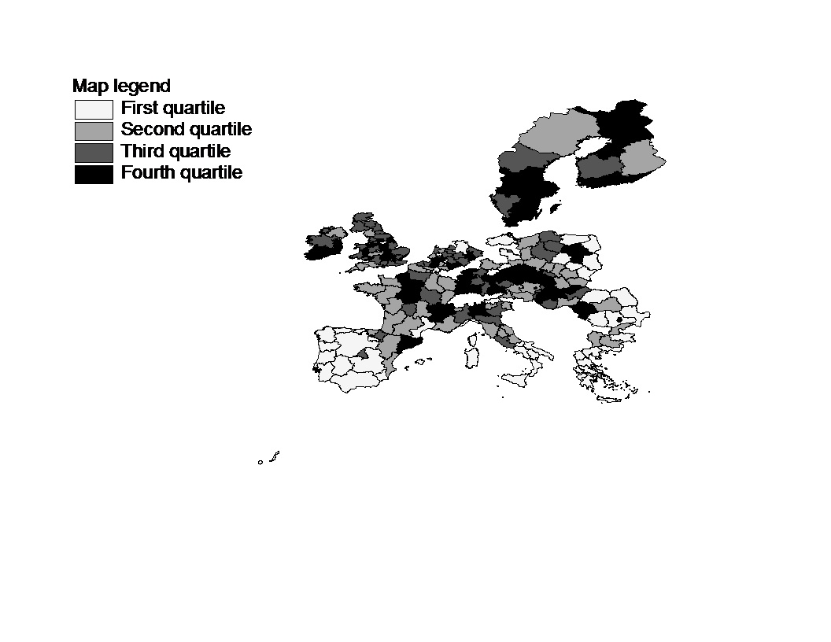

For an application of more general spatial models to industrial location count data see Basile et al. 2012.
Blonigen et al. (2007) consider different motivations for spatial dependence in FDI according to the type of FDI and estimates a spatial lag model (but on a continuous FDI variable: affiliate sales).
The regression has shown that there are significant industry effects in explaining the use of business services across countries for manufacturing (R²=0.58, F=34.83 significant at 1%) and service sectors (R²=0.67, F=51.70 significant at 1%). For more details, see Guerrieri and Meliciani (2005).
For an application of more general spatial models to industrial location count data see Basile et al. 2012.
Blonigen et al. (2007) consider different motivations for spatial dependence in FDI according to the type of FDI and estimates a spatial lag model (but on a continuous FDI variable: affiliate sales).
We have also introduced a large set of institutional variables to capture differences in country characteristics (variables capturing the rigidity of the labour market; the size of taxation; the length of the bureaucracy; etc.). The only variable robustly significant (negative) was the number of procedures for enforcing contracts. Results are available on request.

