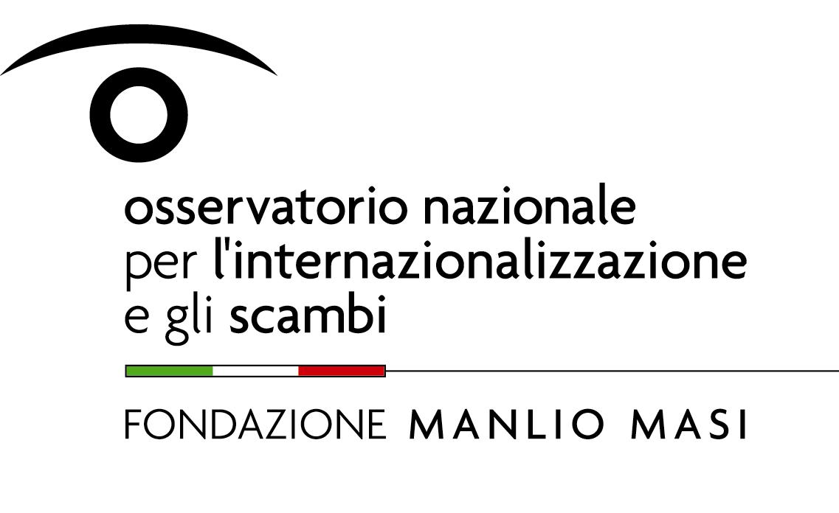 | 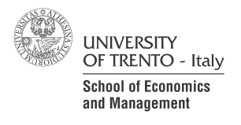
Italian Trade Study Group (ITSG)
International Workshop
International Trade, Firms and Organizations

University of Trento – Department of Economics and Management

Thursday, November 29th

Conference Room “Alberto Silvestri” (ground floor) – Via Rosmini, 44, Trento

14.30 – 14:45 Welcome Address

14.45 – 17.00

SESSION I: Trade and Market Structure – Theoretical Analysis
Chair: Beniamino Quintieri (University of Rome “Tor Vergata” - Fondazione Manlio Masi)
Anders Laugesen and Peter Arendorf Bache (Aarhus University)
Complementary Activities, Heterogeneous Firms, and Industry Structure.
Discussant: Giuseppe De Arcangelis (Sapienza University of Rome)

Letizia Montinari (University of Trento)
Trade, Productivity Improvements and Welfare: An Endogenous Market Structure Framework.
Discussant: Gaetano Alfredo Minerva (University of Bologna)

Philip Ushchev, Sergey Kokovin and Evgeny Zhelobodko (National Research University, Higher School of Economics, Moscow)
Multi-product firms in monopolistic competition: Consequences of opening trade.
Discussant: Chiara Tomasi (University of Trento)

17.00 – 17.30 Coffee Break

17.30 –18.30

Keynote Speech: The Theory of the Firm Goes Global

Dalia MARIN (Ludwig-Maximilians-Universität - München)
Chair: Giorgio Basevi (University of Bologna)

19-19.30 ITSG Meeting

20.00 Dinner (Antico Pozzo – Via Manci, 45, tel. 0461/263657)

Friday, November 30th
DISA Seminar Room – 1st floor, old wing

08.30 – 10.45

SESSION II: Empirical Evidence on Italian Firms
Chair: Fabrizio Onida (Bocconi University)
Stefano Federico and Silvia Del Prete (Bank of Italy)
Trade and finance: is there more than just “trade finance”? Evidence from matched bank-firm data.
Discussant: Stefano Schiavo (University of Trento)

Marcella Nicolini (University of Pavia and FEEM), Carlo Altomonte (Bocconi University) and Dario Pellegrino (OECD)
The impact of Chinese imports on Italian firms’ price-cost margins: An empirical assessment.
Discussant: Michele Bernini (University of Trento)

Andrea Presbitero (Università Politecnica delle Marche), Matteo Richiardi (University of Turin) and Alessia Amighini (Università del Piemonte Orientale)
Is labor flexibility a substitute to offshoring? Evidence from Italian manufacturing.
Discussant: Lucia Tajoli (Politecnico di Milano)

10.45 – 11.15 Coffee Break

11.15 – 13.30

SESSION III: Trade, Factor Movements and Innovation in Europe
Chair: Giorgia Giovannetti (University of Florence)
Valentina Meliciani (University of Teramo), Davide Castellani (University of Perugia) and Loredana Mirra (University of Rome ”Tor Vergata”)
The Determinants of inward foreign direct investment in business services across European regions.
Discussant: Roberto Gabriele (University of Trento)
Cristina Cattaneo, Valentina Bosetti and Elena Verdolini (Fondazione Eni Enrico Mattei and CMCC)
Migration, Cultural Diversity and Innovation: A European Perspective.
Discussant: Andrea Presbitero (Università Politecnica delle Marche)

Daniela Maggioni and Alessia Lo Turco (Università Politecnica delle Marche)
Dissecting the impact of innovation on exporting in Turkey.
Discussant: Giuseppe Vittucci Marzetti (University of Milan Bicocca)

13.30 – 14:30 Lunch

14.30 – 16.00

SESSION IV: Trade Integration and Trade Policy
Chair: Maria Luigia Segnana (University of Trento)
Alessia Amighini (Università del Piemonte Orientale ) and Marco Sanfilippo (Robert Schuman Centre for Advanced Studies, EUI)
Impact of South-South integration on the export upgrading of African economies.
Discussant: Andrea Fracasso (University of Trento)

Enrico Marvasi and Barbara Annicchiarico (University of Rome “Tor Vergata”)
Protection for Sale, Monopolistic Competition and Variable Markups.
Discussant: Jacopo Zotti (University of Trieste).

